Monday 24th September 2018

5.30 – 7.00 pm

Hesters Way Resource Centre

Present
Charmian Sheppard, | Resident, Chair | Bonnie Toner | Resident
Andy Hayes, | HWP | Frank Austin | Resident
Georgie Austin | Volunteer | Anne Holderness, | Volunteer

Agenda Item 1 – Welcome

Charmian Sheppard introduced herself, as did everyone, and welcomed everyone to the meeting.

Apologies received from:

Philip Smith, (HWP), Lloyd Kilford (HWP) Wendy Flynn (CBC)

Agenda Item 1 Data Analysis

The group studied the spreadsheet data that had been generated from the street audit process that had taken place over the summer.

The following are the key points raised during the group discussion;

TREES

It was noted that where trees are well maintained they add a considerable amount to the overall look of the area. In general, most streets are tree lined (75%) and most of those are in good condition (90%+). Where trees are damaged or have been removed they require replacement and some need to be pruned where they are obscuring the light from streetlamps.

Sochi Mews, Ashlands Road, Laxton Road, Montreal and Quebec Drives, Graham Stanley and Falkland Places, and Edinburgh Place require tree additions or replacements

PAVEMENTS

Largely the pavements are in good or very good condition with only 10% of those roads with pavements being graded as poor. These were to be found in the area between PE Way and Newton Road but also on Hesters Way Road and De Ferriers Walk.

SAFE CROSSINGS

Most of the busy roads which would necessitate crossing places are adequately supplied with several notable exceptions;

- PE Way from Fishy Park to Hobart House
- Marsland Road to provide access to St Thomas More School
- Fiddlers Green Lane / Springbank Road roundabout
- Marsland Road / Fiddlers Green Lane roundabout

DROPPED KERBS

To a large extent there are dropped kerbs facilitating easy crossings on most streets in the area though some of these are not located for safe crossing. The key locations of the 15% where improvements could be made are as follows;

- Fiddlers Green / Marsland Road roundabout
- Marsland Road
- De Ferriers Walk
- Hicks Beach Road
- Winterbotham Road
- Blenheim Square
- Russet Road

SIGNAGE ON STREETS

Most streets were signposted reasonably well though many of these could do with sprucing up of the paintwork. Some streets lacked signs at one or both ends or were essentially ineffective;

Missing; Ashlands Road (one end), , Barbridge Road (both ends), Farm Close(one end), .Oddly located; Oldbury Road damaged; Tanners Road (one end), Newton Road repaint required Emperor Close and Peacock Close

ROUTE SIGNAGE (Inc WALKING / CYCLING)

Very few route signs can be found in the area and those that do exits are for through routes, though signs to exist for Springbank, Fiddlers Green including schools, shops and surgeries though these are on the main arterial routes.

Cycling and walking signs are generally from PW Way and Coronation Square towards town. These do not signpost via parks nor are local routes marked for cycling and walking.

Additionally, parks in the area (Fishy Park, Fiddlers Green Park) lack signs at entrances and those entrances are also unwelcoming. Through routes for walking and cycling are consequently not encouraged around the estate would be much improved were this to be the case.

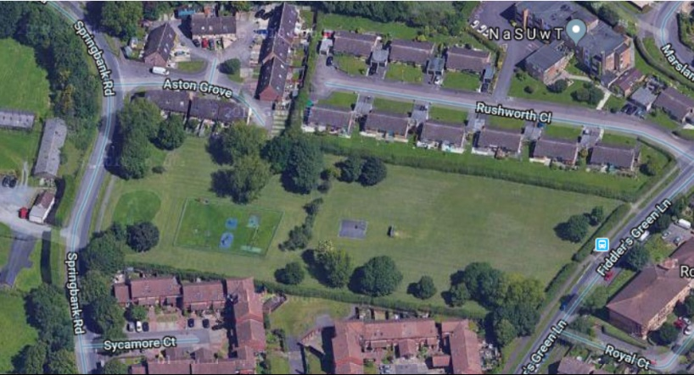
Fiddlers Green Park

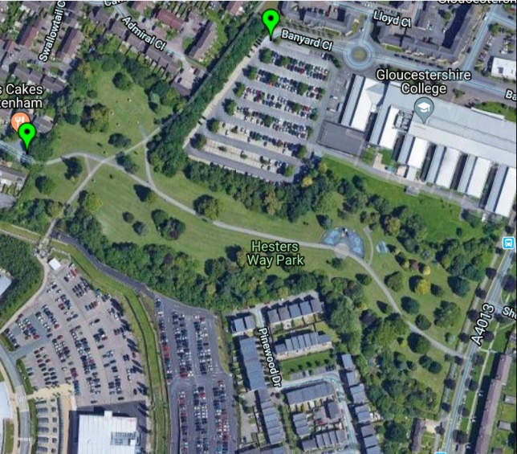

Fishy Park

OPEN SPACES to PROTECT

Blenheim Square Ashlands Road Green

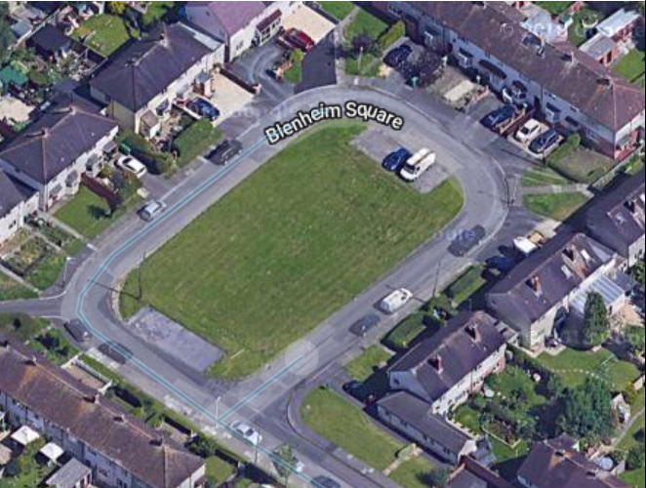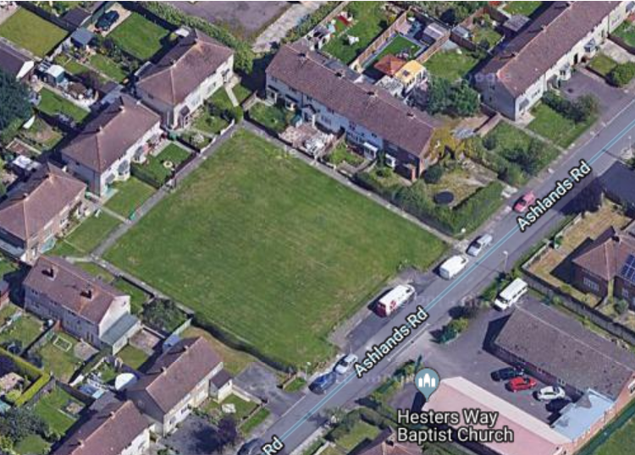

STREET LIGHTING

Over 90% of the street lighting in the ward was rated as good or very good. Key streets where this was not the case are as follows;

Laxton Walk, Sochi Mews, Yalta Close. Tanners Road and Lane, Beverly Court, Brown Road Lechmere Road, Dorrington Walk and De Ferriers Walk all require attention

PARKING

Car parking in the area is generally responsible but there are some areas of concern. It is well known that GCHQ staff and contractors park on the streets in the vicinity of the building. The streets which experience most of the inconvenience are as follows;

Kempton Grove, Fiddlers Green Lane, Galileo Gardens, Coburn Gardens and Brosnan Drive.

Additionally, there are issues of parking which can cause damage to verges and obstruct pathways and dropped kerbs notably here;

PE Way, Pinewood Drive, Sotheby Gardens, Havana Way (these latter 3 may also be GCHQ staff)

The car parks at Hesters Way Community Resource Centre and Oasis also has issue of over use which has limited access for some customers. Overspill from here is catered for at Shakespeare Road and in The Coronation Square car park

POTENTIAL DEVELOPMENT SITES

There are four key development sites;

Ellison Road car park Marsland Road car park

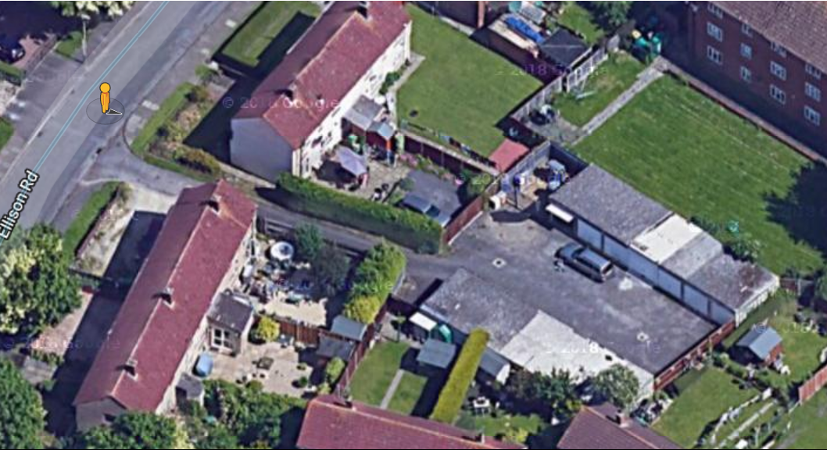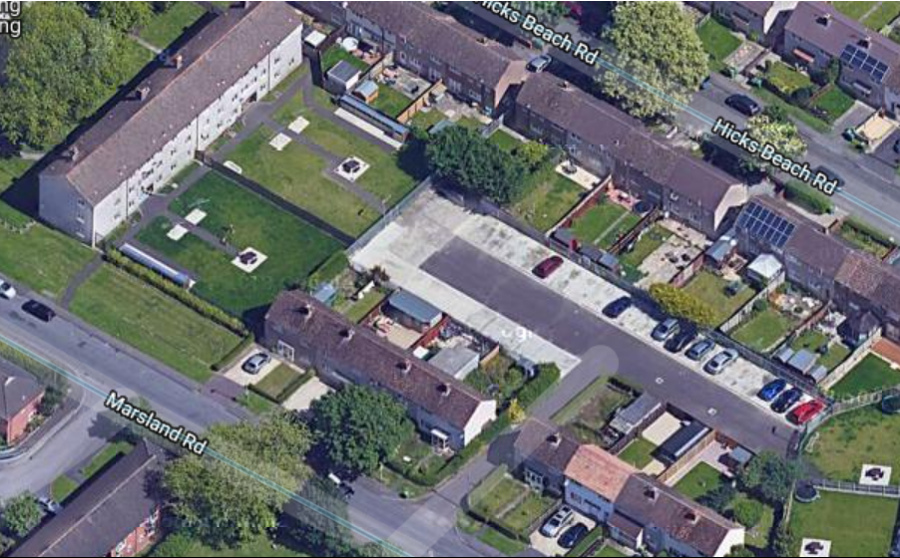

Land to the west Of Fiddlers Green Lane (Cyber Hub development area)

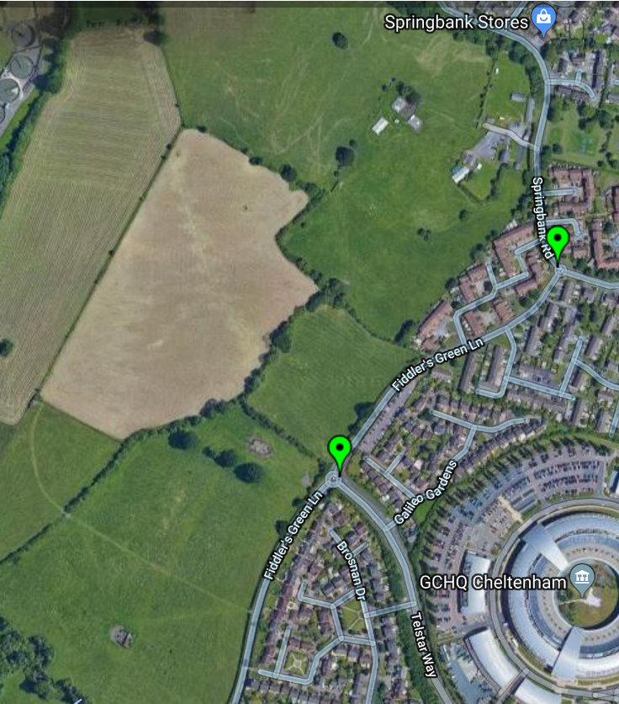

Former St Aidan Church site

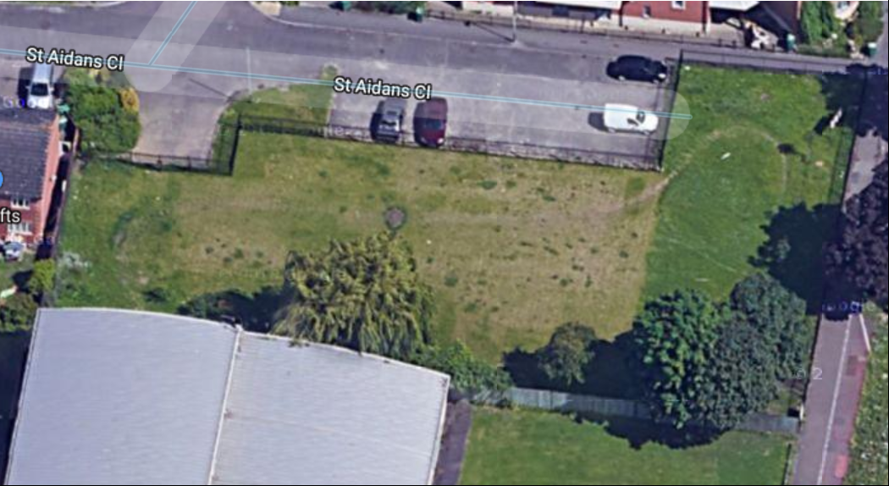

Specific feedback – see the spreadsheet;
- Paths didn’t always follow desire lines
- Signage to local facilities was poor
- Access to Fishy park poor
  - Difficult to cross PE Way
  - No access from North Court
- Signage of Fishy park poor, entrance underwhelming not welcoming
- Some properties were very dilapidated considering their age (North Court)
- Link points between the old and the new areas are important.
- Better vehicular permeability is what is needed to ensure the Springbank and Coronation Square can benefit from the new development.
- Sufficient parking must be made available for employees
- Tall buildings on the edge of the site overlooking properties are undesirable
- Plenty of parkland is made available but should be accessible for the community
- Could a different design offer more for the community e.g. parks and water features accessible from the residential areas e.g. the static home park and the adjacent properties
- Alterations to Fiddlers Green Lane could make access to the site difficult for pedestrians and cyclists
- How will bus routes be sustainable is they don’t pass social housing?

ND Plan Vision document review to be on next agenda

Agenda Item 2 Locality Technical Support

Locality have offered technical support in relation to the Cyber Hub development and Andy agreed to arrange a date for them to come up

AOB

None

The meeting closed at 7.10 pm

Next meeting:

TBC pending Locality visit arrangements

Signed…………………………………………………………………………………………………

Name…………………………………………………………………………………………………..

Dated…………………………………………………………………………………………………..

Actions

 | Actions list
1 | Arrange a date for Locality to visit | AH
2 | Rewrite ND Plan Vision document to include HW area only | AH
3 | Investigate joint NDP developer meeting with Springbank developers | CS AH
4 | Group to find a dedicated volunteer to run the social media for the group * action carried over from May meeting | All
5 | Group to find at least two new steering group members* action carried over from May meeting | All

