Hesters Way, St Marks, Fiddlers Green and Springbank Neighbourhood Profile 2016

Why this profile is being created
This is the first draft of a report that is being formed by Gloucestershire Rural Community Council (GRCC) through research and partnership work with the Neighbourhood Development Forum, neighbourhood coordination groups (NCGs) and communities of Hesters Way, St Marks, Fiddlers Green and Springbank, and Cheltenham Borough Council, in order to give an overview, or ‘portrait’, of the area in 2016. This is being done with the intention of ultimately enabling the community to contribute to the development of the Cheltenham Plan. It is currently based on desktop evidence from national and local data, which has resulted in this discussion draft, which will now be checked by the community to suggest amendments and highlight any gaps in information. This report will evolve as information from community consultation is gathered and added to give more depth.

How this profile has been produced so far
This report has been produced by GRCC through detailed desktop research using multiple sources, planning information and maps from Cheltenham Borough Council and community knowledge. It aims to bring together many kinds of information into one place where communities can check and add to it, and can use existing evidence to inform potential focus of consultation activities in the future.

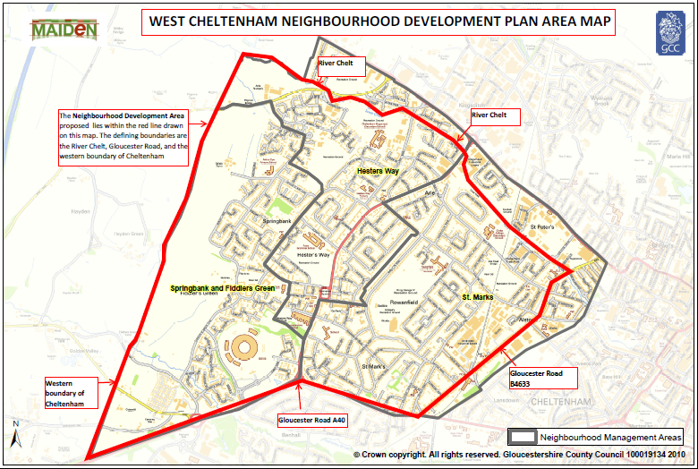

Location
The area of Hesters Way, Fiddlers Green and St Marks is a mature, residential suburban area to the west of the town centre. The area adjoins the town centre to the east, Wymans Brook and Swindon Parish to the north, , and Up Hatherley and Benhall to the south.

NDP map here instead and definition of area as described in that map http://www.hwpartnership.org.uk/resources/West+Cheltenhan+NDP+area+April+2016.pdf

People and Households
Data
Data about people and households in Cheltenham is gathered at a ward level. Ward boundaries are different in places from those of the NDP three NCGs, so it has only been possible to present data from wards that when combined most closely resemble the NDP NCG areas’ expanse. This means that we have used the wards of Hesters Way, Springbank and St Mark’s, which roughly represent the NDP NCG area. The population of these three wards is approximately 19,670.

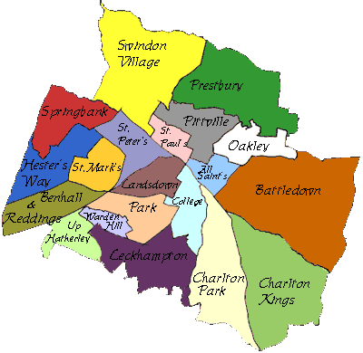

Key facts
Census information for the area indicates that:
- Around 48.9% of residents are male and around 51.1% are female
- There are 33.75 persons per hectare in Springbank and 33.97 in Hesters Way, both ranking in the top 35% for population density in the county. St Mark’s is in the top 10% with 47.0 persons per hectare.
- The population of under-17s is in the top 10% across Hesters Way and Springbank wards.
- The area has some high needs for young people and ranks in the highest 10% in Gloucestershire for the number of emergency admissions, number of free school meals (over twice the county average in all three wards) and English as an additional language. Pupil achievement is patchy, indicating that many pupils may not make good progress at various points in their education. Many other indicators for young people rank in the top 35%.
- Some indicators that affect economy and enterprise ranked in the highest 10%: the number of lone parents and the number of carers are consistently high across the three wards.
- Crime indicators suggest that crime levels are fairly high, with there being 50% more victims of crime in the area than the county average.
- Needs relating to healthy living and older people are varied, with the highest need in the areas of domiciliary care and social work.

Deprivation
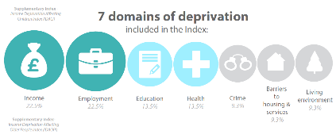
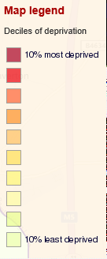
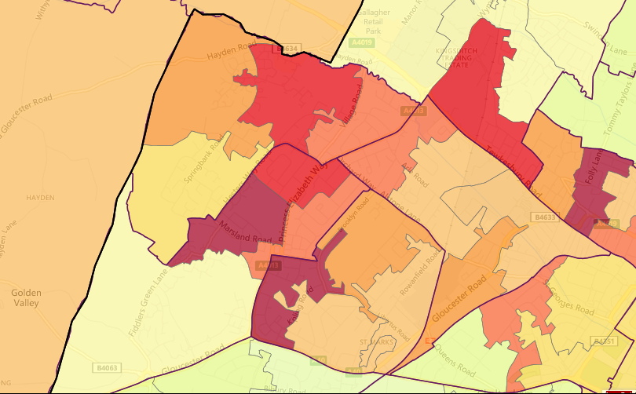
A Lower Layer Super Output Area (LSOA) is a geographic area designed to improve the reporting of small area statistics in England and Wales. Each LSOA is graded based on where it falls in its score for multiple deprivation, across five divisions in the full range. Hesters Way, St Marks, Fiddlers Green and Springbank contain all or part of 17 LSOAs. Of these LSOAs, four are in the highest quintile for deprivation, six are in the second-highest quintile, five are in the middle quintile and two are in the second-lowest quintile. This indicates that the area features a varied level of multiple deprivation, with some households being very deprived.

Educational Achievement
[Graph: Distribution of qualifications within HW Partnership area]
[Graph: % qualifications relative to other areas]
[We need to write a few sentences here after adding the above graphs?

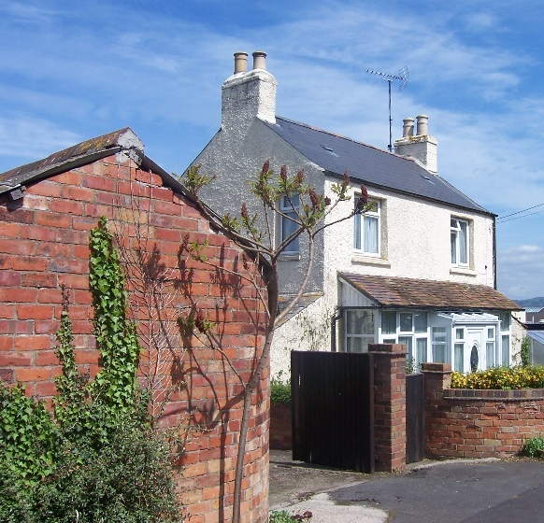
History and Heritage
- St Marks was developed mostly in the 1920s–40s

- The area of Hesters Way was largely fields and farmland until the 1950s, specifically Hesters Way Farm (known as such since early 1800s, and previously as Hesters Way).

- The area was also home to the hamlet of Alstone, to which Alstone Lane used to lead, and the village of Arle, home to Arle Court House, built in the late 16th century and rebuilt in the 19th century.
Springbank Cottage, Hope Orchard

- In the 1930s, Brooklyn Road was developed, followed by Tanner’s Road in 1939.

- Dowty moved to Arle Court in 1935.

- In 1951, Princess Elizabeth Way was built, with Hesters Way housing estate following behind. The estate was built to house the workers of GCHQ (which moved to the area in 1952) and nearby engineering works.

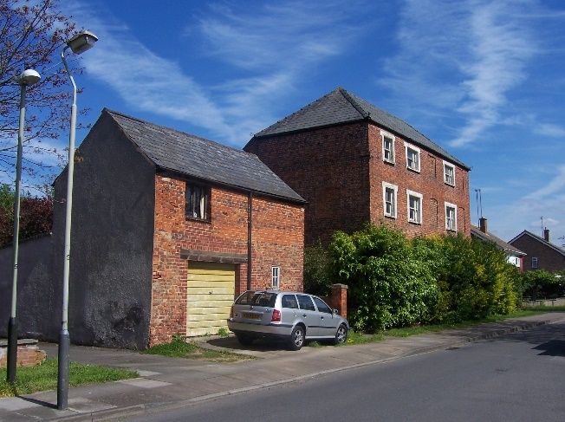
- Most of Springbank was developed in the 1960s and 1970s to accommodate the growing population of Cheltenham. It was built as a mix of social and private houses and remains that way now. The area is named after a cottage built there in 1880, built on a bank above a spring.

- Several newer housing developments close to GCHQ were completed/in progress alongside GCHQ’s rebuild of their main buildings in the 2000s.
Arle Court House, Kingsmead Road.

- Musicians blocks were demolished and replaced with new housing c 2004.

- Many of the blocks of flats on Princess Elizabeth Way have been given facelifts in recent years. Two tower blocks; India and Pakistan Houses were demolished in 2006 and replaced with semi-detached and terraced housing.

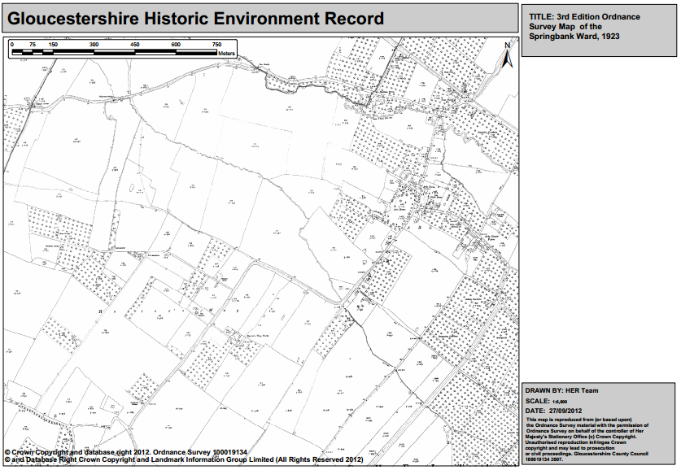
Ordnance Survey map of the Springbank Ward
1923

‘Poets’ conservation area covers the group of houses around Shakespeare Road. The area as described by Cheltenham Borough Council as follows: “Houses are set in well-spaced plots which create a unifying rhythm along the street. Roads are often tree-lined with the trees forming a distinctive visual characteristic of the area. The overall form and layout of the development is based upon 'garden city' principles. There is a strong influence of the Arts and Crafts movement to be found in the architecture of the houses…”.
There are also several listed buildings in the area, although relatively few considering the size of the area. They are as follows:
- Nesley Croft, on Fiddler’s Green Lane
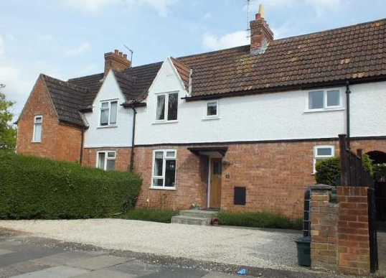
- Two large properties adjacent to the Griffiths Avenue Nature Reserve – one of which is now a care home
- St Marks C of E Church
- Lamp post on the roundabout near the Railway Station
- Vine Cottage on Alstone Lane
- 52, 54 and 58, Alston Lane
- Alstone House
- Cheltenham Gas Company Building and Walls Adjoining (Gloucester Rd)
Milton Road part of “The Poets“
- 2 GRADE ll listed White House, corner of Village Road and Kingsmead Road
- 2 GRADE ll listed Arle Court House, in Kingsmead Road.

Physical Character
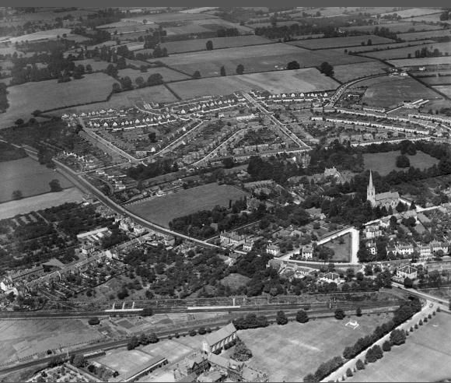
The area is so large that the character is enormously varied throughout. Much of it is residential, with most housing being built during the second half of the 20th century, aside from St Marks and the few houses that formed the original old hamlets and villages. Many streets tend to be fairly uniform, owing to the larger-scale development that occurred rather than infill, but there is a rich variety of building styles, representing architecture from the 1920s through to very recent years.

Unlike the tight Victorian grids of more central Cheltenham areas, the street layout in the area is more modern, from the concentric crescents and joining roads of St Marks to the loops and cul-de-sacs of Springbank. While these non-linear street layouts may have sought to create a more spacious feel, the area does still have a busy character, although not necessarily unpleasantly so. The amount of greenery and open spaces is higher than within the town centre, allowing some ‘breathing space’. The modern nature of many of the houses means that nearly all homes have front gardens, which adds to the spaciousness, and abundant off-road parking means that streets have a more open appearance. Flats tend to be three- or four-storey, and set out in squares or within lawns, again giving a more spacious feel.
St Mark's Estate, Cheltenham, from the south, 1935.

The amount of employment activity nearby adds to the busy nature of the area, with GCHQ based in the Springbank neighbourhood area and Gloucester College based in the Hesters Way neighbourhood area.

[Suggestion: Group can add pictures displaying character here if desired]

Roads, Transport and Access
Roads
Several busy arterial roads run through the area: Princess Elizabeth Way runs north to south and connects the A40 from Gloucester to the A4019 Tewkesbury Road, so is used by through-traffic to avoid the town centre as well as for the retail parks around Tewkesbury Road. Gloucester Road splits from the A40 and runs north-east along the eastern of St Marks before meeting the High Street, so again it serves as a route for traffic destined for the railway station and the north of the town. The southern boundary of Fiddler’s Green and Springbank neighbourhood runs along the A40, which is a very busy route that links Cheltenham to Gloucester and the M5 north and south. Most other roads in the area provide access for residential populations, although some minor arterial roads connect small residential streets with main routes in and around town.

Springbank link road issues

Cycle ways
There is shared-use footway on along Princess Elizabeth Way and a small part of the A40 that can be used by cyclists, and there are bike parking facilities on Edinburgh Place (Coronation Square) and Tewkesbury Road. There are no other dedicated cycle trails or facilities in the area, so cyclists travelling through and around the area currently use the roads. Roads in the area have been graded by the Cheltenham and Tewkesbury Cycling Campaign as being either quiet, reasonably quiet or medium, apart from Princess Elizabeth Way, the A40 and Tewkesbury Road. A higher rating needs a higher level of skill from the cyclist.

Public Transport
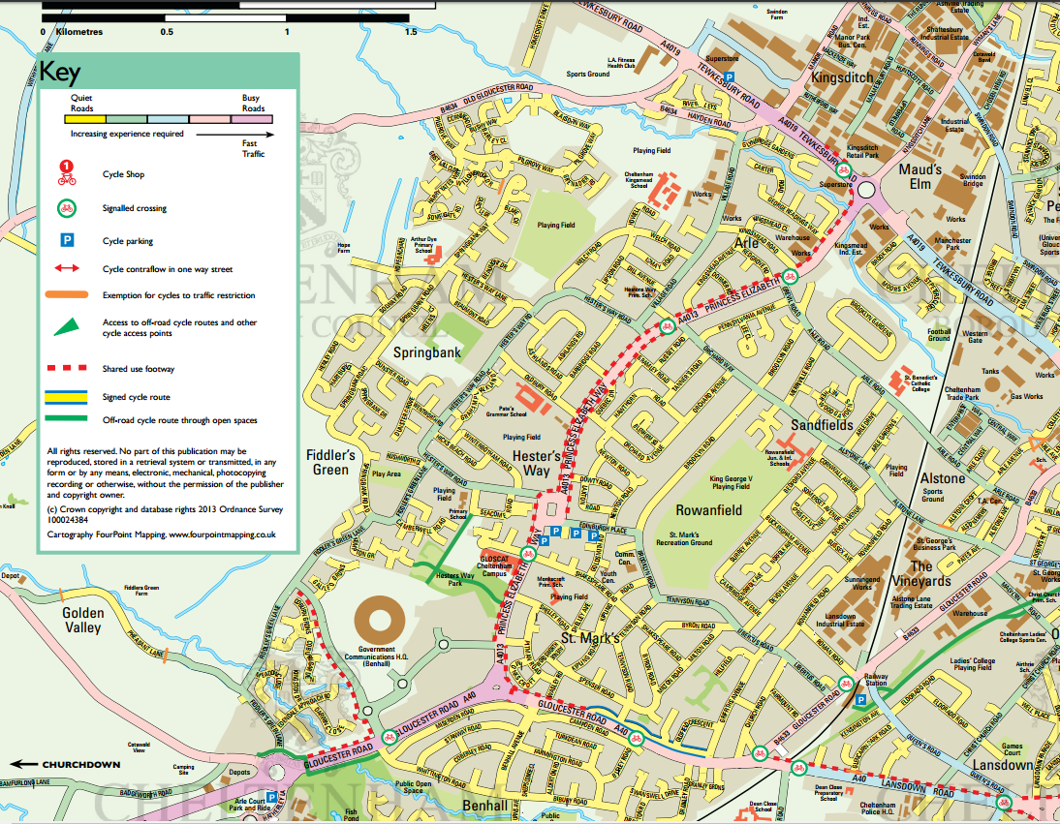
Cheltenham Railway Station is in very easy reach for the residents of St Marks and the lower portions of Hesters Way. For Springbank, the station is roughly 40 minutes’ walk, or 2.4 miles. The bus station is a 1.6 mile or 30-minute walk from the heart of the area (Orchard Avenue in Hesters Way, GL51 7LE), but some buses do go through the area, such as the C (Springbank – Fiddlers Green – Cheltenham), A (Lynworth – Cheltenham – Benhall – GCHQ), B (Springbank – Wymans Brook Cheltenham – Charlton Kings) and F (Rowanfield – Cheltenham – Leckhampton).

Parking
The vast majority of houses in the area have an off-road parking option, meaning that on-road parking is easy for visitors. The high usage of the railway station leads to commuters parking in the vicinity, which can cause parking problems for residents. (A GCC managed parking permit scheme is at the proposal stage) There is one council car park in the area, behind the shops at Coronation Square. Gloucestershire College and GCHQ have their own self-contained parking, meaning that employment parking is largely self-contained. Although there are considerable issues at GCHQ with contractors’ cars regularly parked in local residential streets much to the irritation of locals. Many houses have off-road parking, but parking spaces are more scarce for residents of the many flats in Hesters Way.
Extract from Cheltenham Cycle Campaign Map

Community Services and Facilities
Healthcare
There are two GP surgeries within the area: Hesters Way Healthy Living Centre (Cassin Drive), Springbank Surgery (Springbank Way). There are four dental surgeries in the area or very close by: Springbank Dental Surgery (Springbank Way), Coronation Dental Practice (Princess Elizabeth Way) Michael Dental Care (Fiddlers Green Lane) and 8 Libertus Road Dental Practice (Libertus Road). There are three pharmacies in the area, and these are Lloyds Pharmacy (Coronation Square), St Marks Pharmacy (Tennyson Road), Cheltenham Pharmacy (Springbank Way).

Libraries
Hesters Way Library (Goldsmith Road) is close to the cluster of shops on Coronation Square and operates a limited 21 hours per week service.

Places of Worship
The area has five active churches: Hesters Way Baptist Church (Ashlands Rd), St Barnabas Church (Orchard Way), St Aidans Church (Oasis Centre), St Marks Methodist Church (Gloucester Road) Bethany Gospel Hall (Newton Road) and St Marks C of E Church (Church Road).

All churches offer a wide variety of community engagement and activities including coffee shops, youth groups, toddler / playgroups as well as weekly services and hire of church premises for community groups and activities.

Community Spaces and Facilities
There are three dedicated community centres in the area: Springbank Community Resource Centre (Springbank Way), Hesters Way Community Resource Facility (Cassin Drive, also home to the Chinese Centre) and St Mark’s Community Centre (Brooklyn Road).
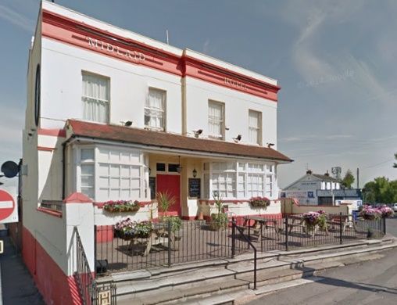
Midland Hotel, Gloucester Road
Pubs
The Midland, next to the train station has a large community space / function room for hire. http://midlandcheltenham.co.uk/
The Umbrella on Orchard Way, is a community pub with a large skittle alley/function room with own bar, pool table and dart board. It also offers skittles and darts teams and regular live music.

There is a recycling bank in Edinburgh Place car park, off Coronation Square.

Community Facilities Map;

https://www.google.com/maps/d/viewer?hl=en&authuser=0&mid=1tz6Xk-tf4Rq7C0xJ_jI9t8I9pHE

This map locates all the venues included in the Hesters Way Partners Directory;

http://www.hwpartnership.org.uk/directory.html

Businesses and Business Parks map;

https://www.google.com/maps/d/viewer?mid=1JFmozVQPp-VWvuFGASh863UTTGU

Recreation and Leisure
There are several sports facilities in the area:
- YMCA Sports Hall (Arle Road)
- Oasis Centre (Coronation Square)
- Otium Leisure Club (Fiddlers Green Lane))

http://www.hwpartnership.org.uk/resources/Hesters+Way+Directory+2016+UPDATE+23+02+2016.pdf

There are several playing fields in the area such as Springfields Park, Triscombe Way, Pilgrove Way and King George V Playing Fields. There is a skate park and MUGA at Springfields Park. The nearest public swimming pool is Leisure@Cheltenham on Tommy Taylor’s Lane, which is 1.9 miles away, or 37 minutes’ walk, from the heart of the neighbourhood area.

Green Spaces
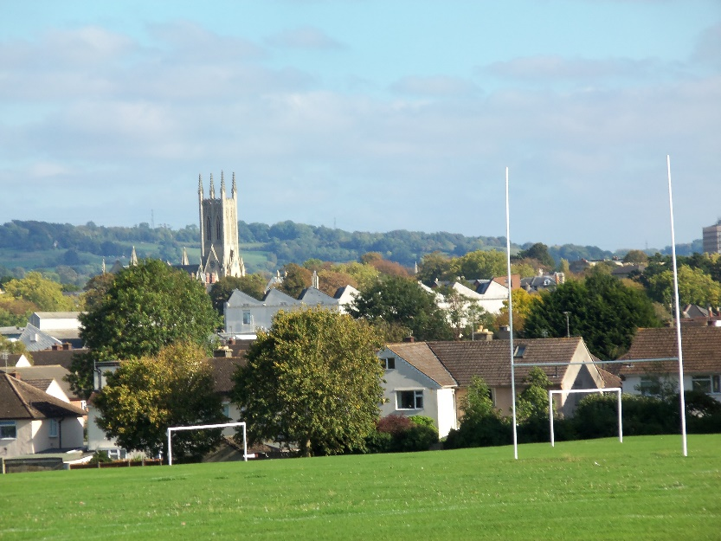
There are a lot of green spaces in the area, some with designations and some without. The green belt of the town runs along the western border of the area. The neighbourhoods took part in the Local Green Spaces Study conducted in 2015 in partnership with GRCC and Cheltenham Borough Council, applying to designate (as local green space) Pilgrove Way, George Readings Park, Triscombe Way, Christ College, Monkscroft School Field and the green space around St Marks Community Centre (decision pending at time of reporting).

Educational Facilities
The area contains six primary schools:
- Hesters Way Primary (Dill Avenue)
- St Thomas More Primary School (Lewis Rd)
- Springbank Primary Academy (Springbank Way)
- Rowanfield Junior School (Alstone Lane)
- Rowanfield Infant School (Alstone Lane)
- Gloucester Road Primary School (Gloucester Rd)

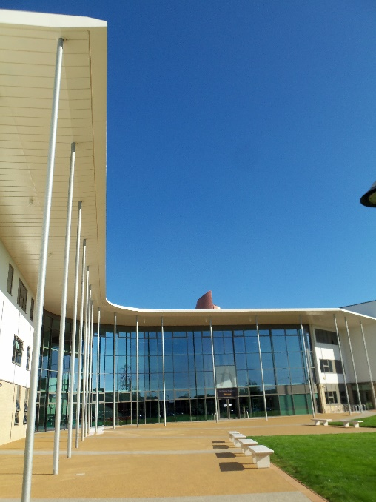
It also contains two secondary schools:
- All Saints’ Academy (state) (Blaisdon Way)
- Pate’s Grammar School (independent) (Princess Elizabeth Way)

The area also contains several early years’ settings, including:
- Puddles Nursery (HWCRC, Cassin Drive)
- Giggles Nursery (Springbank CRC Springbank Way)
- Hesters Way Children’s Centre (Dill Avenue)
- Rowanfield Children’s Centre (Alstone Lane)
- Toddler group at St Barnabas Church
- Toddler group at St Mark’s Methodist Church

see http://www.hwpartnership.org.uk/directory.html

Economy
Employment
The area is mainly residential, so many residents are required to travel out of the area to get to work. However, Gloucester College, Lansdown Industrial Estate and GCHQ offer a number of employment opportunities within the area. The area is a medium length bus ride away from central Cheltenham retail and administrative employment, with the town centre being 2.7 miles away. The concentration of retail and trade along Tewkesbury Road is in relatively easy reach, especially for residents of Springbank.

Income
The area features several parts of Middle Layer Super Output Areas (MSOAs), which are small geographical areas used to analyse average household income in England and Wales 2007–8. According to the data, mapped to show the different MSOAs, there is a very wide range of incomes across the area, the richest being the north-western corner of Springbank with an average of £810 per week at that time. Next richest is the Fiddler’s Green area with an average of £730 per week. Springbank and St Mark’s are in the second-poorest quintile, with an average of £570 and £590 respectively. The lowest income in the neighbourhood is seen in the area flanking Princess Elizabeth way, which was on average just £520 per week at that time.
Retail and Services
The largest retail cluster in the area is around Coronation Square, on the eastern edge of the area. This cluster includes Farmfoods, Iceland, Greggs, Sue Ryder, Age UK, two cafes, two betting shops, a greengrocers, an optician, a travel agency and several takeaways.

There are several smaller retail and service clusters elsewhere in the area:
- Convenience stores on Hesters Way Road, Hesters Way Lane, Springbank Road, Gloucester Road and Arle Road / Merriville Road
- A cluster including a hairdresser, takeaways, butchers, motor shop and convenience store on Tennyson Road
- An empty block of shops at the end of Springbank Way
- Post Office on Hesters Way Road
- Shell garage on Princess Elizabeth Way

Planning Landscape

Recent planning and development had taken place at the White House on Village Road, the former Spirax Sarco site off Tennyson Road and the land on the former Christ College School on Arle Road. Developments have been planned but not agreed behind Lucinia Mews and at Springbank Shopping Centre.

The recent JCS indicate plans pending approval for a new “Tech Hub/ Business Park” on land beyond Fiddlers Green and 500 plus houses on land west of Springbank

Housing
Area | Owned outright % | Owned with mortgage % | Social housing shared ownership % | Social housing rent from CBC or HA % | Private Rental % | Other  %
Hesters Way Partnership | 21.2 | 32.4 | 1.6 | 38.7 | 12.5 | 1.8
Cheltenham | 32.1 | 32.4 | 0.7 | 12.2 | 20.1 | 2.4
Gloucestershire | 35.5 | 33.9 | 0.8 | 12.9 | 13.8 | 3
England | 30.6 | 32.8 | 0.8 | 17.7 | 15.4 | 2.7

Housing Tenure – proportions
Far fewer houses in this area are owned outright than the national, regional or borough averages, but mortgaged properties are roughly in line with local and national averages. Social rentals are very high (25% more social rentals than Cheltenham’s social rent proportion overall and over twice the national average). Private rental numbers are low when compared to Cheltenham overall, but closer to national averages.

Housing types
[We need a way to find data similar to ACRE Rural Evidence reports but for wards as we can not find any breakdown of housing types by ward. Will need to discuss with Hannah at ChBC as they might be able to provide something like this so we can populate the following paragraph)

The most common type of housing in the area is XXXXXXXX (%) with XXXXXXXXX being the next most common (%). XXXXXXXXXX make up % of accommodation in the area, with XXXXXXXXXXXX being the least common type of accommodation at just %.

Housing affordability

Zoopla’s heat map of property prices for West Cheltenham

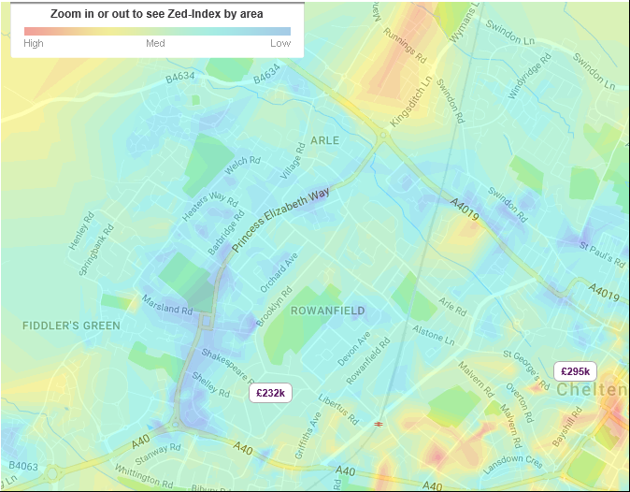

St Marks & Hesters Way Partnership
Area | Owned outright % | Owned – mortgage or loan % | Shared Ownership % | Social –council % | Social – other % | Private Rental Landlord% | Private other  % | Rent free  %
St Marks | 22.8 | 32.9 | 0.8 | 23.6 | 6.1 | 11.0 | 1.5 | 1.2
Hesters Way | 17.5 | 28.4 | 2.1 | 23.8 | 11.8 | 14.0 | 1.5 | <0.1
Springbank | 23.3 | 35.8 | 1.8 | 16.1 | 8.4 | 12.5 | 0.1 | 1.0
Cheltenham | 32.1 | 32.4 | 0.7 | 8.0 | 4.2 | 20.1 | 1.3 | 1.1
Gloucestershire | 35.5 | 33.9 | 0.8 | 5.9 | 7.0 | 13.8 | 1.6 | 1.4
South West | 35.4 | 32.0 | 0.8 | 5.8 | 7.5 | 15.2 | 1.9 | 1.4
England | 30.6 | 32.8 | 0.8 | 9.4 | 8.3 | 15.4 | 1.4 | 1.3
Source: ONS 2011 Census
Amended for graphs
Area | Owned outright % | Owned with mortgage % | Social housing shared ownership % | Social housing rent from CBC or HA % | Private Rental % | Other  %
St Marks | 22.8 | 32.9 | 0.8 | 35.8 | 11.0 | 1.5
Hesters Way | 17.5 | 28.4 | 2.1 | 47.4 | 14.0 | 1.5
Springbank | 23.3 | 35.8 | 1.8 | 32.9 | 12.5 | 0.1
*Hesters Way Partnership | 21.2 | 32.4 | 1.6 | 38.7 | 37.5 | 1.8
Cheltenham | 32.1 | 32.4 | 0.7 | 12.2 | 20.1 | 2.4
Gloucestershire | 35.5 | 33.9 | 0.8 | 12.9 | 13.8 | 3
England | 30.6 | 32.8 | 0.8 | 17.7 | 15.4 | 2.7
*this figure was calculated by adding the totals for St Marks, Hesters Way and Springbank and dividing by 3 to get the mean.

Area | Owned outright % | Owned with mortgage % | Social housing shared ownership % | Social housing rent from CBC or HA % | Private Rental % | Other  %
Hesters Way Partnership | 21.2 | 32.4 | 1.6 | 38.7 | 12.5 | 1.8
Cheltenham | 32.1 | 32.4 | 0.7 | 12.2 | 20.1 | 2.4
Gloucestershire | 35.5 | 33.9 | 0.8 | 12.9 | 13.8 | 3
England | 30.6 | 32.8 | 0.8 | 17.7 | 15.4 | 2.7

MAIDeN mid-2013 population estimates
MAIDeN Neighbourhood Profiles
https://www.cheltenham.gov.uk/info/52/conservation/644/cheltenhams_conservation_areas/9
www.britishlistedbuildings.co.uk
Google Maps
Google Maps
ThinkTravel website: http://www.thinktravel.info/files/uploads/Cheltenham_Bus_Map_V2.pdf
All information in this section taken from the 2011 Census

