Monday 25th February 2019

5.30 – 7.00 pm

Hesters Way Resource Centre

Present
Charmian Sheppard | Volunteer, Chair | Mike Newby | Resident
Suzanne Williams | Councillor, | T. Wheat | Resident
Andy Hayes, | HWP | Anne Holderness | Volunteer
Wendy Flynn (Cllr) | Resident | Jim Lodge | Resident
Jon Glover | Police | Maureen Dolan | Resident
Bonnie Toner | Resident

Agenda Item 1 – Welcome

Charmian welcomed everyone to the meeting. Each attendee introduced themselves to the group

Apologies received from: Lloyd Kilford (HWP), Georgie Austin, Frank Austin, Colin Prottey, Susan Runciman

Minutes of the previous meeting approved

 | Actions list
1 | AH to provide information and share with the group re A40 and Junction 10 developments. DONE – by email and on website | AH
2 | AH to investigate the possibility of technical support from Locality re traffic numbers and pollution – See agenda | AH
3 | The masterplan document to be strengthened in respect of the traffic / transport points made. Done and sent to Locality for review by inspector latest version 8th Feb available on website | AH
4 | Consideration of a separate transport section be added to the Neighbourhood Plan to take account of the whole area. Yet to be done | Steering group
5 | AH to investigate existing reports / possible measures re current trees and wildlife status with a view to ensuring future protection. See biodiversity survey 2008. CBC Tree officer reported that trees could be protected prior to developer plans are prepared | AH
6 | All attendees to do desktop / site study of green spaces near their homes ready for the next meeting – see agenda | ALL
7 | Attendees to review aims and objectives paperwork at home ready for the next meeting. - see agenda | ALL
8 | Attend Cheltenham Borough Homes drop in re Monkscroft Villas flats on PW Way at Hester’s Way Community Resource Centre from 3.30-6.30pm on February 6^{th.} Some attendees had visited – general feeling was that the proposed 27 flats and 3 houses were a good use of the site, in keeping with the newer developments in the area and well designed. There were some concerns form the police regarding the security of the roof garden, but these were being addressed | All welcome

Agenda Item 1 Cyber Hub Masterplan Feedback  The masterplan document had been amended by Macdara Nidh at AECOM and is available on line. Andy had asked if any further amendments could be made but the deadline for technical support had closed and the document was being sent to Locality for review. The reviewed document was not available so discussions and feedback had to be delayed until the March meeting when it should be available. AH to post online when available  Agenda Item 2 Aspirations Review  Wendy presented a paper prepared earlier with regard to clarifying the vision and aspirations for the group. The following was suggested as a vision for the plan;  “A safe, green and sustainable place that people are proud to call home, with leisure and community facilities that are inclusive and encourage community cohesion. A connected place where people thrive.” All to consider amendments if / where necessary  A discussion of the aspirations based on those originally prepared as a result of earlier work with GRCC was held. See here http://hesterswayforum.co.uk/wp-content/uploads/2019/01/CECP_Part_2_Chapter_8_St_Marks_Hesters_Way.pdf  AH to amend aspirations to take account of the discussion (see aspirations document)  Aims and Objectives Review – it was agreed that the aims and objectives originally agreed as part of the constitution document were still valid;  - Draw up a plan for the future development of the area.  - Further the social, economic, health, educational and environmental well-being of Hesters Way Cheltenham.  - Allocate sites for business, retail and housing development including affordable housing.  - Plan for public realm improvements and consider and recommend improvements for the street environment in the area.  - Express aspirations for transport, traffic and parking.  - Ensure developments mitigate against the effects of climate change.  - Seek to protect existing buildings/areas of note and worth.  - Aim to support local businesses, associations, organisations and employers.  - Consider and recommend improvements for the street environment in the area.  - Seek to protect and improve community resources and facilities such as libraries, community centres and public facilities.  - Consider how to protect green spaces and bring environmental benefits to the area.  - Involve as many residents, local workers and local businesses in the process as possible.  - Attract wide support for the plan across the area, taking in a range of views.  - Campaign to have the plan adopted by relevant bodies and by referendum.  - Work to maintain and update the plan as necessary.  - Plan to improve community safety.  The further discussion of terms of reference (ie the latter part of the constitution was deferred until the next meeting. All attendees were asked to take a look at the document to see if it is still relevant;  http://hesterswayforum.co.uk/wp-content/uploads/2017/01/Hesters-Way-Neighbourhood-Development-Constitution-11-10-17.docx#  Agenda Item 3 Green Space Audit  A desktop study of green spaces was conducted and spaces for sport and play, dog walking and general leisure were pinned to an aerial map of the ward. (Apologies as a couple of red dots fell off in transit!)  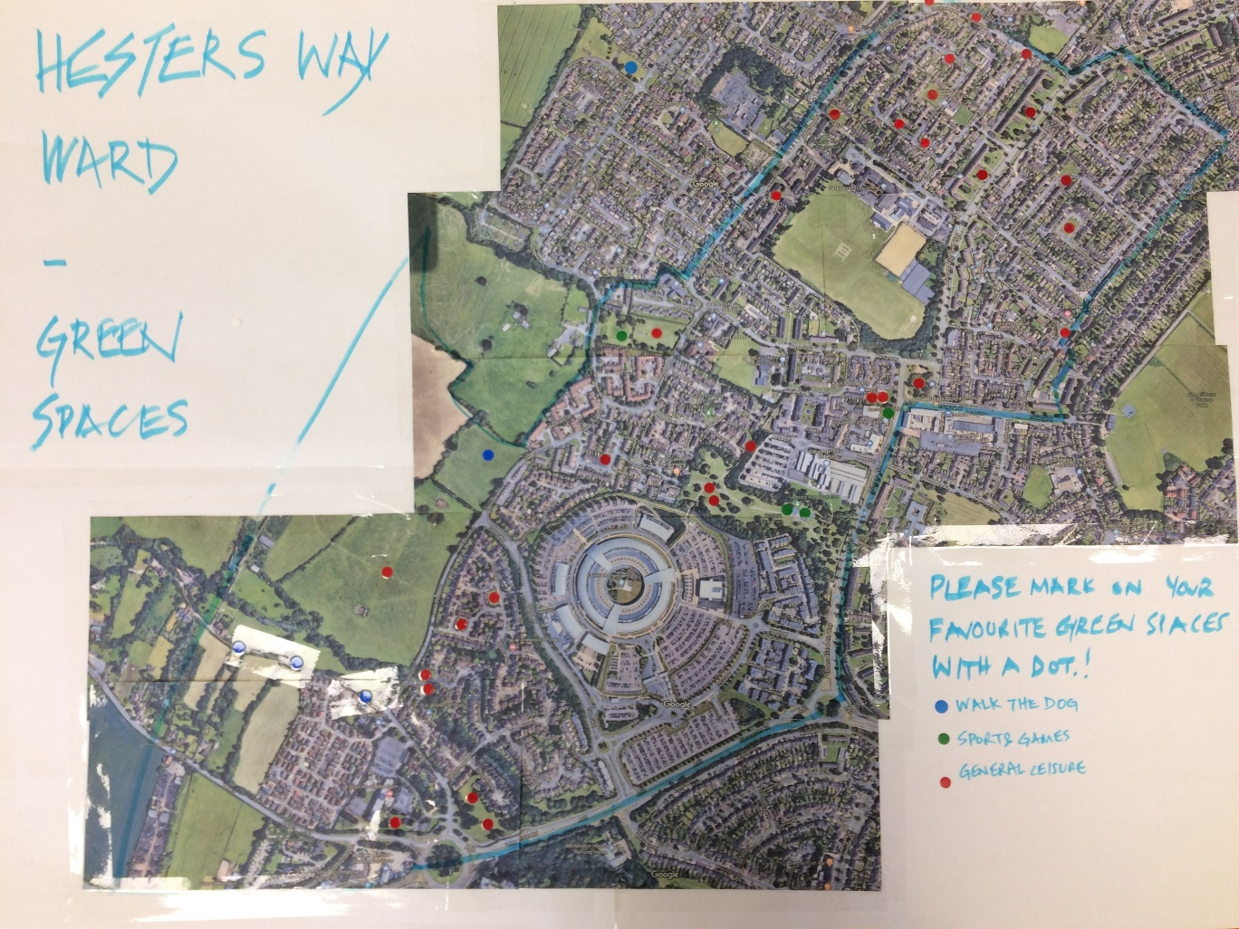  Environment / Wildlife / Trees  It was agreed that the Cyber Hub development could have significant effects on the local environment and that although a Biodiversity Survey had been conducted in 2008 further technical support could be useful in preparing updated versions of one or more of the following;  • Environmental Impact Assessment (EIA);  • Strategic Environmental Assessment (SEA);  • Habitats Regulation Assessment (HRA); and  AH to ask Locality and Gloucestershire Wildlife Trust for advice in relation to the Fiddlers Green meadow / fields and Hatherley Brook waterway.  AOB  The meeting closed at 7.10 pm  Next meeting:  Monday 25th March 2019  5.30pm – 7pm  Hesters Way Community Resource Centre  Signed…………………………………………………………………………………………………  Name…………………………………………………………………………………………………..  Dated…………………………………………………………………………………………………..  Actions  Actions list  1 The masterplan document to be posted online once received from Locality AH  2 All to review vision statement above and consider amendments if / where necessary All  3 Attendees to review constitution document ready for the next meeting. ALL  4 AH to investigate the possibility of technical support from Locality re environment / habitat etc AH  5 AH to amend aspirations to take account of the discussion AH  6 Consideration of a separate transport section be added to the Neighbourhood Plan to take account of the whole area Steering group  7 All attendees to do photograph green spaces near their homes and send to andyhayes@hwpartnership.org.uk ALL  8 Future meetings 5.30pm on Monday 25th March, Hesters Way Community Centre 5.30pm on Monday 29th April, Hesters Way Community Centre 5.30pm on Monday 22nd May, Hesters Way Community Centre ALL | AH  All  AH  All  AH

