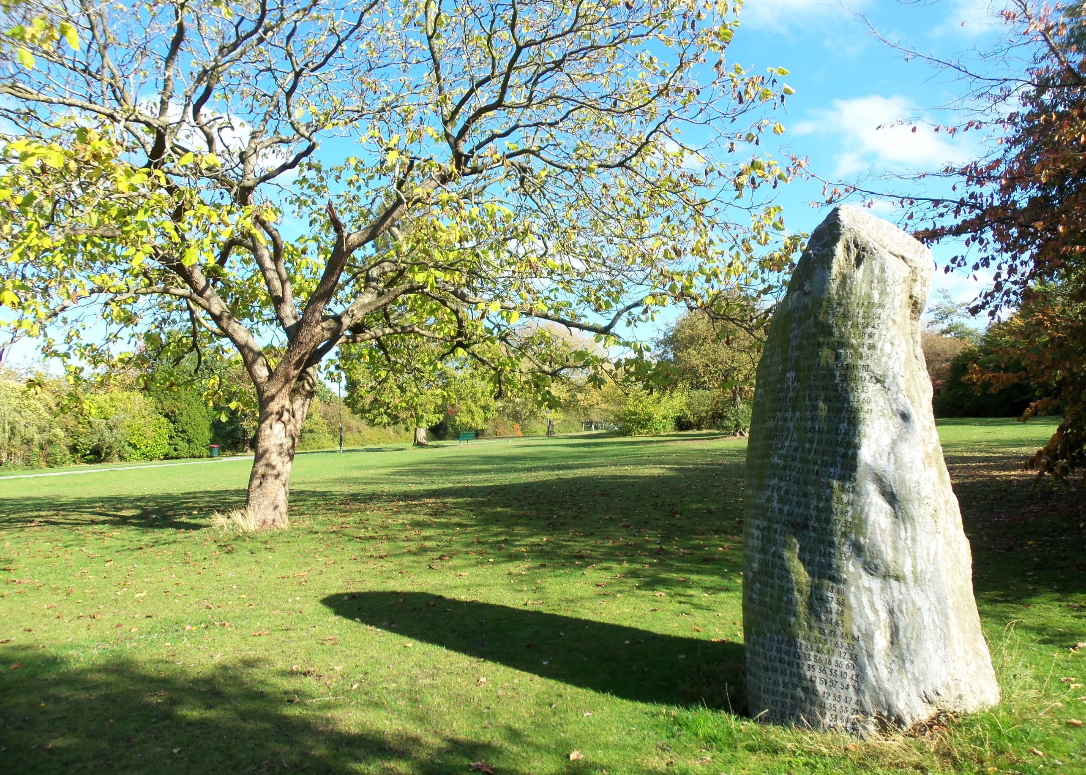

Hesters Way

Neighbourhood Plan
Contents

1 Introduction
2 The Plan Area
3 What is a Neighbourhood Plan, and why do we need one?
4 Background and History
- History
- Heritage
- Landscape and natural environment
- Population and demographics
- Employment and Economy
- Facilities and amenities
- Transport and parking
- Housing
- Community
- Other significant local factors (tourism, agriculture, fishing, harbour, industry etc)
- Conclusions
5 Vision and Objectives
- Objectives
- Environmental Impact Assessment
- Community Projects
6 The key issues
- Housing including affordable housing
- Sustainability
- Infrastructure
- Facilities, Amenities and Services
- Commercial Development
- Renewable Energy
- Use of CIL
- Landscape (inc Open Spaces)
- Heritage
- Allocation of Sites
7 Consultation and Evidence base
- Consultation events
- Evidence
- Policies
- Community Projects
- Monitoring and Review
8 Appendix A: Policy Template
- A1 Designation letter

Introduction
01

A Neighbourhood Development Plan (NDP) is a community-led framework for guiding the future development, regeneration and conservation of an area. A platform for local people to shape their surroundings.
What is the legal position?
The Localism Act 2011 established the right of communities to prepare NDPs if they can gather 21 people from across the whole community to form a Neighbourhood Development Forum which must allocate a Neighbourhood Development Area and be approved by the community and Cheltenham Borough Council. There is a legal requirement for local authorities to support those preparing NDPs. The community must be consulted on the detail of the NDP and critically 50% must vote for it at a local referendum. The statutory status gives NDPs far more weight than parish plans, community plans and village design statements.
What is its scope?
An NDP may deal with a wide range of social, economic and environmental issues such as housing, employment, heritage and transport or it may focus on one or two issues only relevant to the whole or just part of the neighbourhood; it is for those producing the plan to decide it’s focus.
What will it include?
An NDP concerns the use and development of land and may contain;
- a vision
- aims and objectives
- proposals for improving the area
- proposals for providing new facilities
- allocation of key sites for specific kinds of development
- planning policies
Hesters Way Forum
The Hesters Way Forum (HWF) has been set up by residents, employees and volunteers based in the Hesters Way ward in west Cheltenham to produce an NDP for the ward. The HWF is managed by a steering group including a chair, treasurer and small committee.
At the initial meetings held in 2016 the nascent HWF decided that a plan area would be bounded by the River Chelt to the north, the Gloucester Road to the east and south and the town boundary to the west. Unfortunately, this area was rejected by Cheltenham Borough Council but subsequently a ward-based application was submitted and designated in December 2017.
In the absence of a local parish council the HWF feel that the best way for local people to have a say on the future developments in the area is to produce an NDP. The HWF have been set up with the express intention of involving local people’s ideas and opinions to inform the plan.
The HWF have been awarded grants from Locality the government body administering the NDP process to help with technical support in preparing the NDP including public engagement, professional fees, data analysis, environmental assessment, meeting rooms, conferences, printing, staff time, advertising and publicity.
Joint Core Strategy and Local Plan
The NDP if approved will form part of a legislative framework which defines what local development takes place. The most powerful strategic arm of the framework is the Joint Core Strategy (JCS) which defines new developments in specific areas of Gloucestershire, including part of the Hesters way ward.
The Cheltenham Plan is the Borough Council’s plan for future development in the town outside those areas designated as JCS. Any proposals included in the NDP cannot override these documents but take account of local context and can add detail and flavour to the main strategic approaches

Plan Area
02

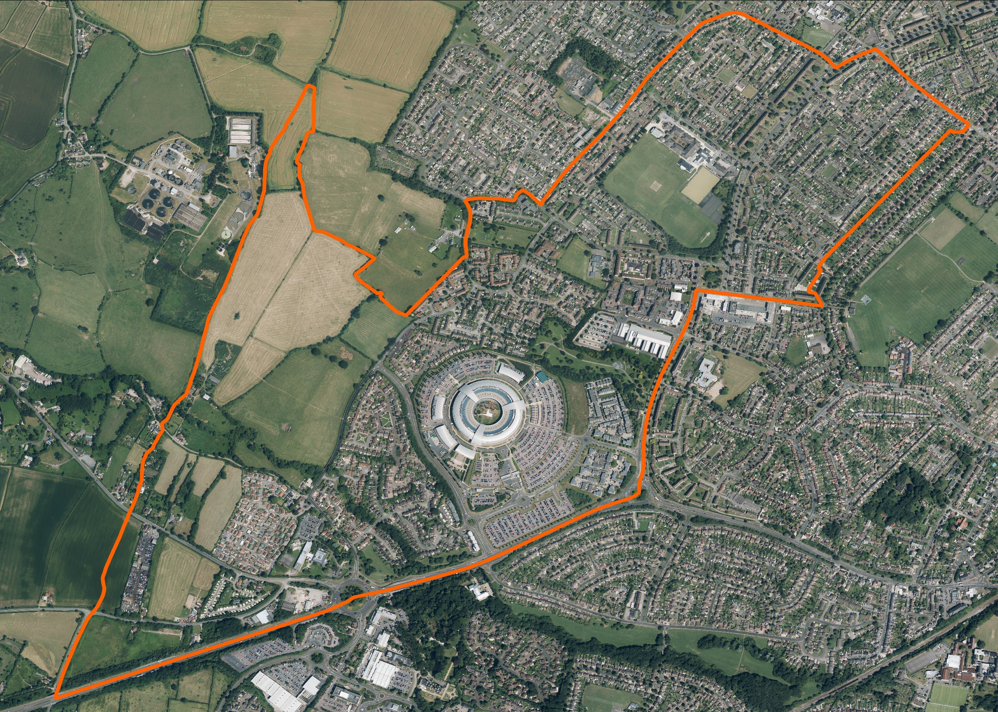
Neighbourhood Plan; Hesters Way Ward, Cheltenham
Hesters Way Neighbourhood Plan Area

What is a Neighbourhood Plan?
03

The HWF chose the Hesters Way ward area as the development area in consultation with local people which was approved by approved by the Borough Council Cabinet on December 5th, 2017 (Appendix 1).
Preparation of the plan
For the NDP to be successful it must be developed in consultation with a wide cross-section of the local community and be in general conformity with existing strategic local planning policy i.e. the Joint Core Strategy (JCS) and Cheltenham Plan, and with the National Planning Policy Framework (NPPF)
Non-strategic policies should be used by local planning authorities and communities to set out more detailed policies for specific areas, neighbourhoods or types of development. This can include allocating sites, the provision of infrastructure and community facilities at a local level, establishing design principles, conserving and enhancing the natural and historic environment and setting out other development management policies.
Neighbourhood planning gives communities the power to develop a shared vision for their area. Neighbourhood plans can shape, direct and help to deliver sustainable development, by influencing local planning decisions as part of the statutory development plan. Neighbourhood plans should not promote less development than set out in the strategic policies for the area or undermine those strategic policies16.
Once a neighbourhood plan has been brought into force, the policies it contains take precedence over existing non-strategic policies in a local plan covering the neighbourhood area, where they are in conflict; unless they are superseded by strategic or non-strategic policies that are adopted subsequently.
Key Issues and Themes
Initial consultation indicated key issues as;
- The proposed cyber hub
- Transport Infrastructure
- Green spaces and corridors
- Play and community facilities
- Sustainability
- Affordable housing
Draft Consultation
The draft plan must be subject to a 6-week consultation with the public, statutory consultees and the local authority
Submission and examination
The NDP is passed on to the Local Planning Authority for an independent examination This submission will include;
- A map defining the plan area
- Consultation statement
- The proposed Neighbourhood Plan
- A statement regarding the fulfilment of the basic conditions and legal requirements
Should the NDP require minor modifications these are made, and the plan is passed over for public referendum. If the examination shows that even with changes, the plan will not meet the basic conditions it will then be rejected outright.
Referendum
People on the electoral register will be entitled to vote on the question; “Do you want Cheltenham Borough Council to use the NDP for West Cheltenham to help decide planning applications in the neighbourhood area?” If more than 50% of those voting say yes then the local planning authority will bring the NDP into force.
Implementation
Planning applications to the planning authority at Cheltenham Borough Council must meet the criteria proposed in the NDP before being accepted.

Background and History
04

History of West Cheltenham

The urbanisation of the west of Cheltenham has occurred to a large degree since the turn of the last century having previously been a rural backwater dedicated to arable farming and orchards notably those at Hope Farm, Arle Farm and Arle Court Farms, a brick works and a mill on the River Chelt.
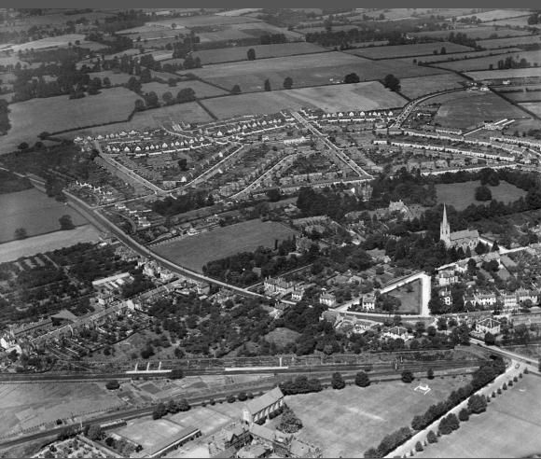
However, recent archaeological excavations on the site of the All Saints Academy prior to its construction in 2011 revealed a much longer history. The survey unearthed evidence of pre-historic activity, Roman and early Medieval settlement and the remains of two human burials radiocarbon dated to the 7th century. Other early finds from the area include Roman pottery and coins from the former allotment site at Howell Road and a Neolithic stone axe head from the former Tungan site on Village Road.
St Mark's Estate from the south, 1935. Hesters Way now lies on the fields beyond as shown in the adjacent1999 photo
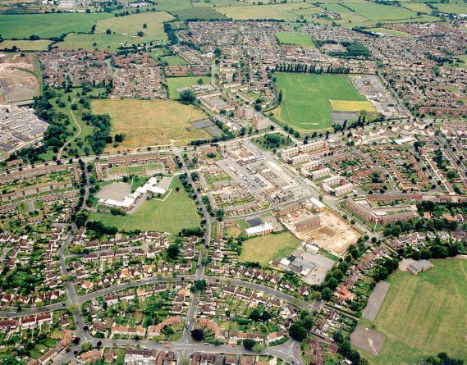
It is the developments of the 20th century have most significantly shaped the character of the area. The initial growth occurred in the inter war years with the construction of the St Marks estate in the south of the area which began in 1921. This area is now designated as a conservation area whose roads are named after famous British writers, hence the nickname “The Poets”.
New Cheltenham Corporation (Borough Council ) housing developments in Hesters Way were planned for the post war period and land was purchased for this purpose between 1945 and 1953. In 1951 Princess Elizabeth visited and planted a tree to mark beginning of the construction of the new estate. Along with hundreds of new council houses there were developments including accommodation for GCHQ staff who moved to the Benhall site on 1952, schools, churches, a library and new shopping centre in Coronation Square completed in 1960.
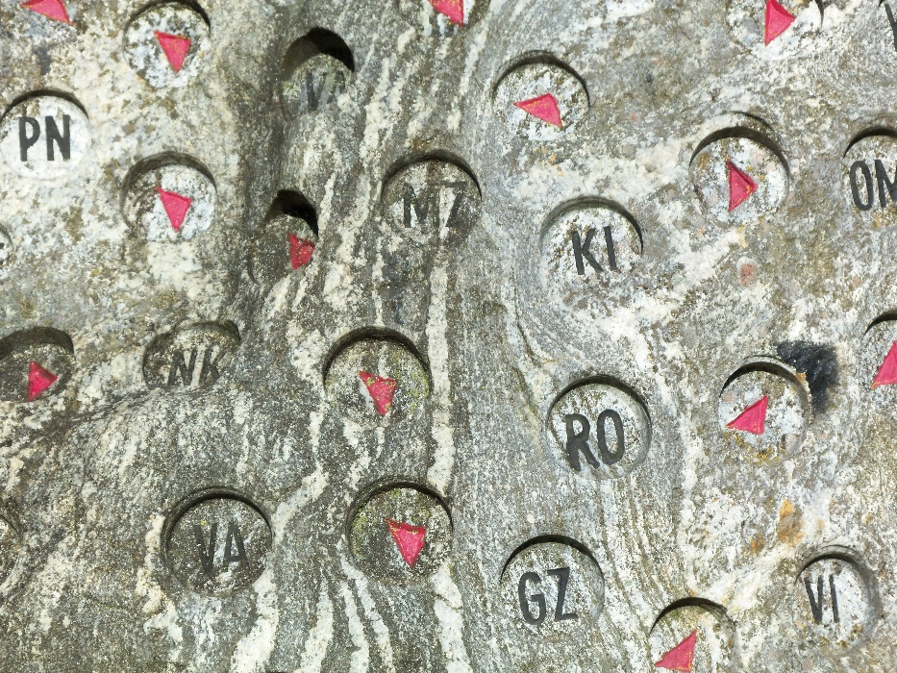
Having had some of its sports field compulsorily purchased to make way for the estate Pates School moved from its town centre site to establish a new school in 1965, three further schools opened before 1975 to accommodate the rapidly expanding population. In the meantime, developments saw housing estates at Netherwood Gardens in filling the gap between the 1930s Brooklyn Road and Gardens with the art deco style properties at Arle Drive. This urban growth continued with privately funded developments being responsible for housing in Fiddlers Green, Springbank and Cavendish Park. Further developments have taken place filling in many of the gaps including land adjacent to GCHQ and Newlands Park in Springbank.
Cypher design on one of the listening stones in Hesters Way (Fishy) Park adjacent to GCHQ; by George Young 2004
However, many of the housing developments of the late 50s and early 60s had failed to provide either the physical or social and community benefits originally intended. In 1995 a regeneration project was devised by the Borough Council based on recommendations of the PIEDA report commissioned to establish the reasons for the decline. The result was the demolition of India and Pakistan Houses (Tower blocks on Coronation Square) Sochi Court (opposite the shops on Edinburgh Place) and their replacement with terraced houses and low-rise flats. The blocks on Princess Elizabeth Way were remodelled and improvements made to the through road.
The most significant developments were arguably on the site of the former Monkscroft Secondary School which included the new Glos College campus, Oasis Youth Centre, Hesters Way Community Resource Centre and Police Station. These great new builds combine with the redevelopment of the GCHQ “doughnut” completed in 2002 to offer great hope for the future.

Population and demographics

Census information for the area indicates that:
- Around 48.9% of residents are male and around 51.1% are female
- There are 33.97 persons per hectare in Hesters Way, ranking in the top 35% for population density in the county.
- The population of under-17s is in the top 10% in the Hesters Way ward.
- The area has some high needs for young people and ranks in the highest 10% in Gloucestershire for the number of emergency admissions, number of free school meals (over twice the county average in all three wards) and English as an additional language. Pupil achievement is patchy, indicating that many pupils may not make good progress at various points in their education. Many other indicators for young people rank in the top 35%.
- Some indicators that affect economy and enterprise ranked in the highest 10%: the number of lone parents and the number of carers is consistently high across the three wards.
- Crime indicators suggest that crime levels are fairly high, with there being 50% more victims of crime in the area than the county average.
- Needs relating to healthy living and older people are varied, with the highest need in the areas of domiciliary care and social work.

Total Population |  | Aged 0-15 |  | Working age population |  | Aged 65+ |  | Dependency ratio
6,880 |  | 1,525 |  | 4,465 |  | 890 |  | 0.54
49.8% male; 50.2% female |  | 22.1% (England average = 19.1%) |  | 64.9% (England average = 62.8%) |  | 13.0% (England average = 18.0%) |  | England average = 0.59
Source: Mid-Year Estimates (ONS) 2017

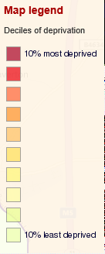
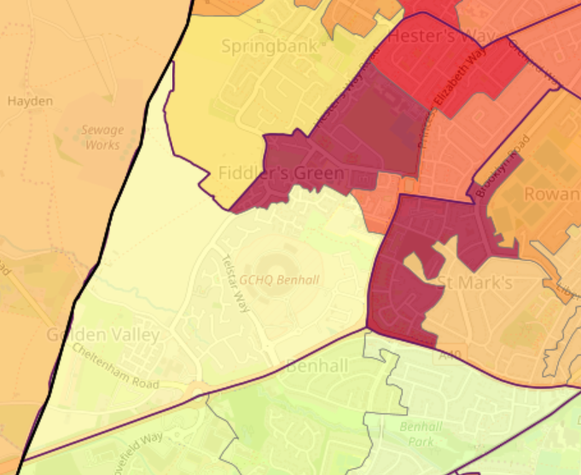
Deprivation

An analysis of data in Hesters Way indicates it as an area of multiple deprivation. However, the ward is made up of a diversity of communities which are not necessarily evident from a desktop study. The map of the Lower Super Output Areas (LSOAs) here shows the disparity across the area.

dclgapps.communities.gov.uk/imd/idmap.html

A LSOA is a geographic area designed to improve the reporting of small area statistics in England and Wales. Each LSOA is graded based on where it falls in its score for multiple deprivation, across five divisions in the full range. Hesters Way contains two LSOAs in the highest quintile for deprivation, one in the second-highest quintile and one in the second-lowest quintile. This indicates that the area features a varied level of multiple deprivation, with some households being very deprived
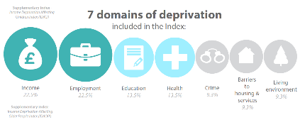
Area Boundary GCHQ Coronation Square . Hesters Way Community Centre

Hesters Way General Statistics

Population | There are 6,880 people living in Hesters Way Ward | Education & skills | 23% of people have no qualifications in Hesters Way Ward compared with 22% across England
Vulnerable groups | 24% of children are living in poverty in Hesters Way Ward compared with 17% across England | Economy | 44% people aged 16-74 are in full-time employment in Hesters Way Ward compared with 39% across England
Housing | 3% of households lack central heating in Hesters Way Ward compared with 3% across England | Access & transport | 30% of households have no car in Hesters Way Ward compared with 26% across England
Crime & safety | The overall crime rate is lower than the average across England | Communities & environment | The % of people 'satisfied with their neighbourhood' (84.5%) is higher than the average across England (79.3%)
Health & wellbeing | 16% of people have a limiting long-term illness in Hesters Way Ward compared with 18% across England | THINK! | The data for the area is made to appear stronger by the inclusion of the housing to the west of GCHQ and Fiddlers Green. Without this the overall picture would be more serious.

Heritage

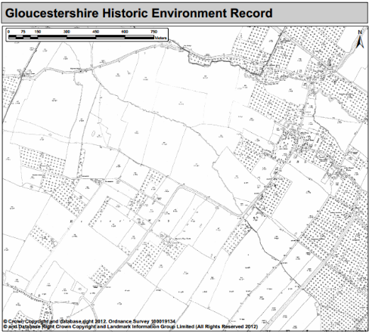
The area of Hesters Way was largely fields and farmland until the 1950s, specifically Hesters Way Farm (known as such since early 1800s, and previously as Hesters Way).

In 1951, Princess Elizabeth Way was built, with Hesters Way housing estate following behind. The estate was built to house the workers of GCHQ (which moved to the area in 1952) and nearby engineering works.

The Cheltenham Grammar School renamed Pates after its merger with the Girls Grammar in the 1990’s was relocated from its former town centre site to the sports field off Princess Elizabeth Way in 1967. The school was designed by Chamberlin, Powell and Bon who also developed the Barbican in London and was uncannily similar to the Murray Edwards College (formerly New Hall) built in 1962-66.

Several newer housing developments close to GCHQ were completed/in progress alongside GCHQ’s rebuild of their main buildings in the 2000s.

Musicians blocks were demolished and replaced with new housing c 2004.

Many of the blocks of flats on Princess Elizabeth Way have been given facelifts in recent years. Two tower blocks; India and Pakistan Houses were demolished in 2006 and replaced with semi-detached and terraced housing.

There is only one listed building in the area; Nesley Croft, on Fiddler’s Green Lane.

http://historyofhestersway.co.uk/

Landscape and natural environment
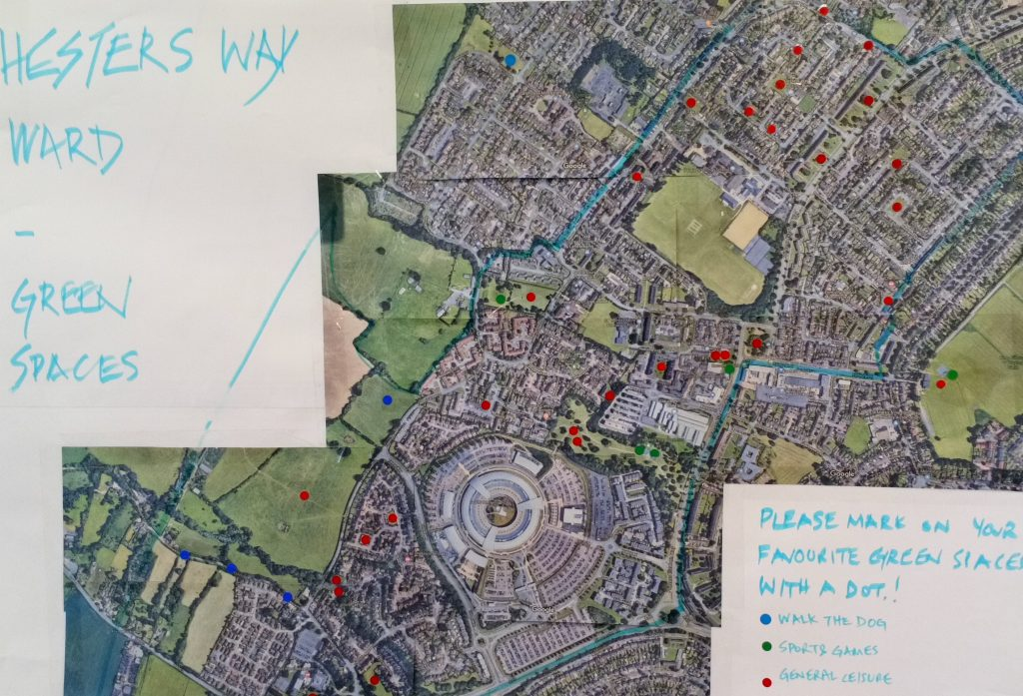

The natural environment is precious to the forum. Research and workshops at forum events identified aspects of the area which are cherished and improved;
- Wildflowers planting on grass verges especially evident around Coronation Square
- Improvements to planting at Benhall roundabout including more attractive, lighter -leafed trees
- Increased spring bulbs including daffodils on verges.
- Hester’s Way in bloom could be a possible action
- Green buffer on Pheasant lane & Hayden Lane
- Main parks eg KGV and Fishy Park should be protected from development
- Develop a destination park
- Park facilities to include
  - Bigger swings
Comment on the landscape, including any waterways or open spaces, are there any land designations (AONB, SSSI, AGLV etc) are there any county wildlife sites? Which areas are valued by the community and used for recreation? Is your area coastal; if so, comment on the beaches, cliffs and dunes. Are there any flood zones, is land used for agricultural purposes? What green spaces are used by the community, are there any compelling views. A map showing key landscape areas and identifying wildlife or protected sites may be useful. What open spaces are used and valued by the community?

  - Zip wire
  - Water play
  - Older children catered for
- Protect green spaces from development
- Deep drainage
- Appropriate trees

Employment and Economy

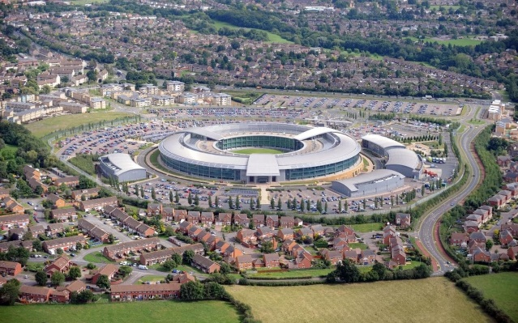
The local economy od Hesters Way is dominated by GCHQ but there are a number of other medium sized employers and the Coronation Square shopping centre is immediately adjacent to the area though lies in St Marks ward.
What we have:
- GCHQ
- Gloucestershire College
- Hesters Way Community Centre
- Jury’s Inn
- Opportunities – Cyber park
- Coronation Square retail (adjacent to the area)
- Small number of shops on Hesters Way Road and Pheasant Lane

The Forum has held numerous events at which the development of local economy and business have been discussed. The key considerations are:

- Employment – skills, facilities
- Opportunities for local people –suitable local employment fitting skills of the area and training available
- SMEs
- GCHQ improved local liaison esp. re parking and noise of air con systems

Business and Retail Development
- Office space (affordable / business/ shared spaces)
- College / schools involved
  - Apprenticeships
  - Local employment
  - Knowledge / experience
  - Pooling resources / overheads
  - CSR
  - Young enterprise
- All day parking / park and ride
- Credit union
- Access to town via public transport
- Promote and strengthen partnerships between large and small private businesses, Cheltenham Borough Council and other public bodies, the voluntary sector and wider community, enabling these partnerships to work better together to improve the local community.
- providing a signposting service to new and established businesses, enabling them to access business advice and support services
- establishment of influential local traders associations in West Cheltenham
- organised tailor-made training courses and seminars to meet the needs of small business people
- individual visits to local businesses in order to assess their successes and needs
- compiled a comprehensive local business directory
- working in partnership with Cheltenham Borough Council departments and local agencies eg Growth Hub looking at area-wide strategies
- working with Business in the Community and large companies, including Spirax Sarco, Travis Perkins, NatWest and Lloyds TSB, to broker better community investment programs
- establishing a Business Partnership Programme, where participants from large businesses are partnered with local business people in an exchange of skills and experience
  - Business mentors (in schools)
- Publicity campaigns / shopping destination /
- Make an attractive place to run business
- Business club / retail group
- Business directory / networking
- Market
- Good free parking
- Businesses involved in community
What employment opportunities exist within the parish – do people commute in to work or do they commute out to work elsewhere? What businesses exist within the parish- how many people work from home, how many commute in and out of the parish for work? Could your parish support more employment - if so, where? What kind of work is available nearby, what are the local wages like – can local people afford to buy or rent a home? Is the area dependent on tourism or industry or agriculture? Do people work from home – are there lots of small businesses; how many empty shops are there; how many are charity shops? Is there a business park or industrial estate – if so, is it thriving or are there vacant units? Have you asked the local business community for their views on the neighbourhood plan and the steps that might be necessary to improve the economy or employment prospects of your area.

Facilities and amenities
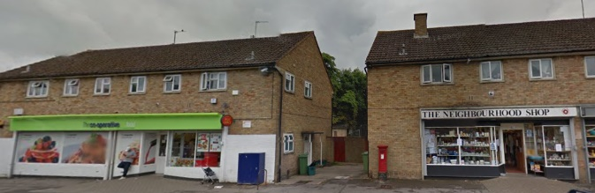

What we value: - Important to retain what we have:-
- Market that can grow –valued
- A good network of clubs/associations
- Faith groups/schools/centres
- Youth groups (Brownies/scouts/Boys’ brigade)
- Exercise classes (Belly dancing/zumba/balance)
- A library
- Slimming clubs
- Ability hub
- Children’s centre
- Nurseries/pre-school
- Make more use of existing facilities
- Offer more facilities esp. large halls
- Oasis for craft events
- Places for adults to meet eg pub?
What is needed/issues to address:
- Encourage people to get out more!
- Banking/Post Office/Credit union (Access to finances is important)
- Venue/Entertainment
- Health services/Pharmacy
- Pub/Café/Restaurants with a pleasant outlook/ view - eg in Parks
- Sports/Bowling Green
Health
- Translation services
- Minor Injuries Unit / Health centre required
- Pharmacy on site of health centres
- Full services available form health centres (eg bandaging)
Schools – where do the local children go for their primary and secondary schooling – are these schools at capacity or do they have spaces? Comment on doctors, hospitals, shops, pub, Post Office, libraries, play facilities, community centres or halls, sports facilities etc. Do these exist, are they thriving? Do any of them need to be protected? Where do people go for their main shopping needs? Are there any allotments? Where are most of the facilities based – if they are all or mostly located in a single settlement then this is likely to be the most sustainable location for further development.

Transport and parking

- Junction 10 M5 opened to relieve traffic in the area.
- Improvement in the bus services and routes linking man centres– either arrive all at once or not turning up at all
- Adequate car parking for new builds (Flats housing and business)
- Paving stones to be replaced all over town where needed
- GCHQ new employment builds to supply adequate parking for workers
- Safe walkways through grass areas
- More safe pedestrian areas in all car park areas
- Apply by-law parking restriction for paths and grass verges (to prevent obscuring vision).
- Restricted access streets for improved cycle and pedestrian safety and convivial living
- Cycle and pedestrian permeable routes across the area and towards the town centre
- Green transport schemes for local businesses and community centres
- Good busses A and C
- Consideration for parking in new developments
- Encourage more bus use so less need for parking
- Shops and services – face the community they serve
- Develop walking routs with signage (eg Oak leaf of English Heritage/ feet or animal signs on pavements)

What public transport exists, where does it go and how frequently. Is a car a necessity or could you exist with just public transport? Is there parking near to facilities? Think also about connectivity in terms of foot and cycle paths. Are there any dangerous or busy roads or junctions?

Housing

Timespan of development 1870-2016
- 1900 - Old Farm properties/Glos Road
- 1920 - St Marks Estate
- 1930 - Arle Drive, Brooklyn Road
- 1950s – Princess Elizabeth Way/Concrete Houses
- 1960s – Various in fill
- 1970s – Springbank/Fiddlers green
- 1980s – Springbank/Fiddlers Green
- 1990 – Various in fill
- 2000s - Also- Christ College (Saxon) / Newlands/ Village Road / Spirax/ N/S Court
What do we need?
- Affordable (including management)
- Mixed ownership/ tenant
- Varied price
- Well designed
- More 2 bed houses

To consider:
- Redway:
- Houses with multiple occupation (HMOS)
- Quality+
- Eco +
- Parking
- Listed Properties – consider new
- Redevelopment policies are needed for houses with multiple occupation

Vision: Good Developments to include
- Green spaces overlooked by property
- Green spaces will linked to housing
- Parking sufficient for housing
- Trees (Appropriate)
Consider the needs of the local community in terms of affordable housing. Are there large numbers of second or holiday homes? Can local people afford to buy homes? How many dwellings are there – what is the density, what tenures are most common – is there a shortage of any particular type of accommodation? What has been built within the parish recently – have these developments been successful – have they included affordable housing. Are there suitable homes for people to downsize to as they get older? Is there an existing settlement boundary? Does this need to expand to allow for some additional growth? Do you want to allocate specific sites for housing or employment – this will give you maximum control over development in your area but can be an involved and difficult process.

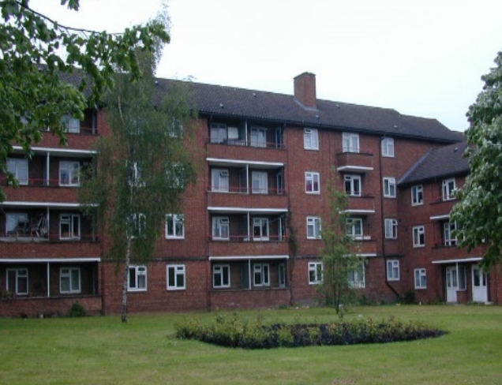
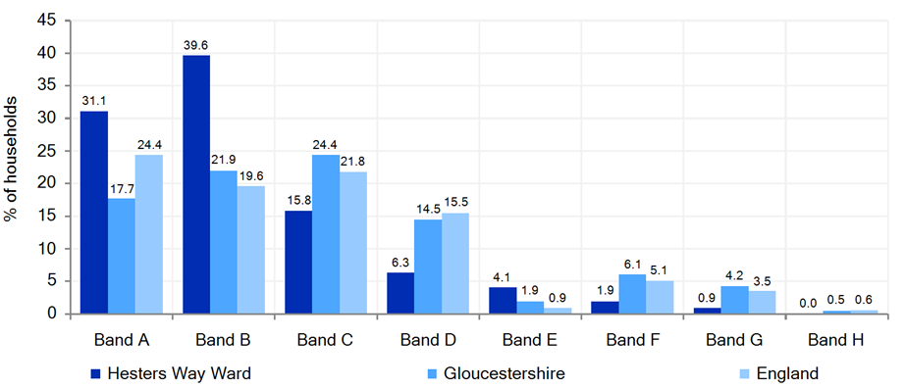
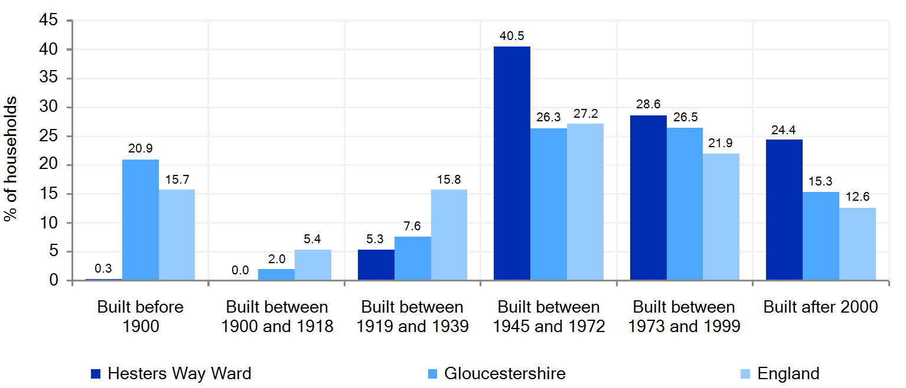

Housing Affordability

Zoopla’s heat map of property prices for West Cheltenham

Community

What markets, festivals and events are regular features in the calendar – how do these contribute to the sense of place?

Other significant local factors (tourism, agriculture, fishing, harbour, industry etc).

Comment on any area-specific issues or concerns. What is special about your parish?

Conclusions

From your analysis and understanding of your Parish, what factual conclusions can you draw from the evidence presented so far? Is the population ageing, are house prices beyond the reach of local workers, are facilities stretched etc?

Vision and Objectives

05

Vision and Objectives

Vision statement;
“A safe, green and sustainable place that people are proud to call home, with leisure and community facilities that are accessible and inclusive and encourage community cohesion. A connected place. A place where people thrive.”
- A green and sustainable local community where people are proud to live
- The area will be a place where old and young people can meet and gather and enjoy company and activities together with leisure and community facilities suited to all needs for the good of the community
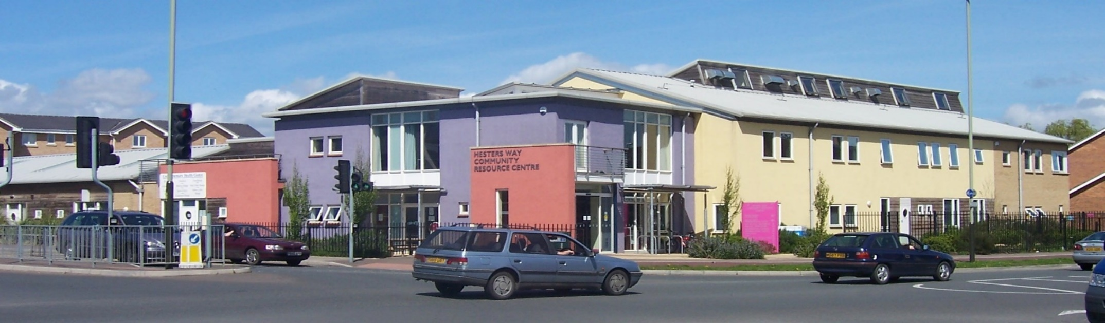
- To cherish and protect the buildings valued by the community
- To ensure connectivity between green spaces
- To have spaces with vibrant spaces that people are proud of and which are visually inspiring.
- To ensure that any future development takes into consideration the current housing provision including type, design and layout in relation to green space and industrial / retail allocation.
- To ensure businesses can be retained and attracted to the area offering local residents employment opportunities.
- To ensure the area will be a place where everyone is safe, has adequate access to transport with consideration taken for sustainability.
- To ensure that leisure and community facilities are suited to all needs for the good of the community.

Aspirations

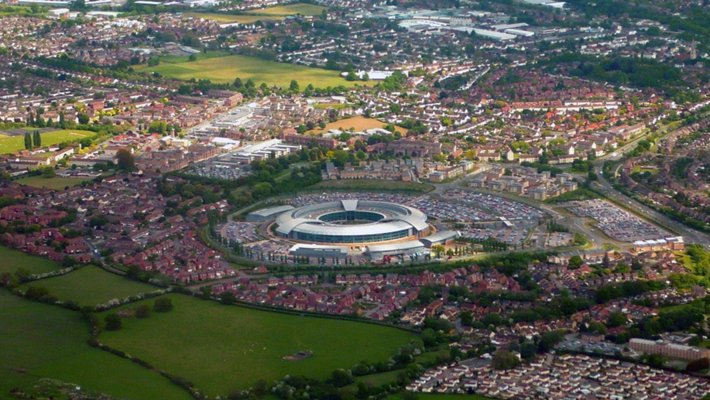
Aspiration 1: To cherish and protect the buildings valued by the community.
The achievement of this aspiration requires the following objectives to be met:
- Develop a list of existing well known and loved buildings in the area to be maintained for continued use and historical benefit
- Promote those buildings with significant meaning to the community
Aspiration 2: To ensure that any future development takes into consideration the current housing needs (including type, design and layout) in relation to green space, parking, recycling and industrial / retail allocation.
The achievement of this aspiration requires the following objectives to be met:
- Integration of local shops/services/ indoor and outdoor ‘meeting spaces’ into any new development (encourages mixing and counters antisocial behaviour)
- Efficient road design around any new developments.
- Low carbon developments to meet best practice standards
- Ensure businesses provide sufficient onsite parking for all employees and contractors
Aspiration 3: To ensure connectivity between green spaces.
The achievement of this aspiration requires the following to be met:
- To obtain all information on green spaces – their use, ownership, size, access, value to public, why it needs protecting.
- To develop walking routes with signage
- To ensure that further housing developments factor in linkages with green space.
Aspiration 4: To have vibrant and healthy and happy spaces that people are proud of and which are visually inspiring.
The achievement of this aspiration requires the following to be met:
- To encourage wildlife corridors to ensure vibrant flora and fauna
- To ensure that the main parks (e.g. KGV and Fishy Park) are protected from development
- To source a business to sponsor for a park warden to maintain/clear/parks
- To develop a destination park
- Quality parks and play spaces for all ages within short walking distance
Aspiration 5: To ensure businesses can be retained and new ones attracted to the area, offering local residents employment opportunities.
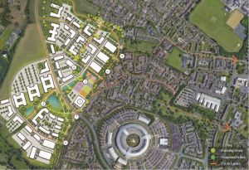
The achievement of this aspiration requires the following to be met:
- To ensure local retail centres are valued and given equal priority by Cheltenham Borough Council to the town centre sites.
- Promote and strengthen partnerships between large and small private businesses.
- Establishment of influential local traders’ associations.
- Providing a signposting service to new and established businesses
- Encourage co-working spaces, small businesses and self-employment
Aspiration 6: To ensure the area will be a place where everyone is safe.
The achievement of this aspiration requires the following to be met:
- Design to minimise crime
- Design to encourage a feeling of safety and ownership.
- Broad and well-lit thoroughfares
- Minimal alleyways and “hidden” spaces
- Green spaces which are clearly overlooked by homes
Aspiration 7: To ensure the area will be a safe place to cycle and walk and has adequate access to transport with consideration taken for sustainability.
The achievement of this aspiration requires the following to be met:
- Managing the flow of traffic and parking in the area
- Joined up cycle routes
- Streets prioritising walking and cycling
- Cycling and walking routes to work/shops / schools.
- Green transport schemes for local businesses and community centres
- Improvement in the bus services and routes linking main centres to the local area.
- Sufficient car parking areas are created adjacent to new homes to avoid the need for on street parking.
- Consideration for parking in new developments

Aspiration 8: To ensure that leisure, health, education and community facilities are suited to all needs for the good of the community.

The achievement of this aspiration requires the following to be met:
- Prioritisation of facilities to be tailored to the community
- To be able to use community facilities more flexibly
- Expansion of services to meet community needs

Environmental Impact Assessment

Comment here on the outcome of the EIA and whether it was identified that Strategic Environmental Assessment (SEA) or Habitat Regulation Assessment (HRA) were required. If either SEA or HRA were required, then explain here the reasons for the study and the outcome in the final report.

Community Projects

Your NDP can only have policies that relate to the use of land but it is likely that as you go through the consultation process, you will identify other issues that are important to your community. You may want a separate section on Community Projects where these issues that cannot be addressed through planning policies can be captured and taken forward outside of the plan. You may also want to set out the areas that the NDP cannot directly influence, or those issues that are adequately addressed by the Local Plan.

The Key Issues
06

The Key Issues

Using your evidence base and responses from the consultation, what have you identified as the key issues for your neighbourhood? Once you have identified the issues and proposed a way of dealing with it, we can consider the wording of a policy that will achieve this – your LPA may be able to help with the drafting of actual policy.
Use the section headings (you may not need all of them) below to think about some key issues and add in any other relevant areas. Using the table format at the bottom of this section, set out the problem, proposal and justification for each issue that you want to address. It is likely that you will need to complete more than one table for each section to address a wide variety of policies

Housing including affordable housing

What types of housing will be required in the future, how much new housing is required? Where should new development be built? Which sites would you like to see protected from development? Do you want to have a say on how new housing should look? Are there residents within your community that are finding it hard to find a suitable home? Do you need to develop new tourist accommodation or student accommodation, perhaps additional supported housing for older residents is key. Consider the current settlement boundary – is this still the best boundary, does it need to be reviewed to allow for additional growth?

Sustainability

How can you ensure that development in your community is sustainable? This section should have regard to the social, economic (including the viability of development) and environmental implications of development (including the consequences of not developing).

Infrastructure

Is there a requirement for new infrastructure, or a need to safeguard existing infrastructure. Are there sufficient school places nearby? Are the roads sufficient to support any planned expansion in housing? Should the town or village centre be protected, should there be restrictions on shops or pubs being converted to residential, on the development of edge of town retail etc.

Facilities, Amenities and Services

What should be protected? This can include shops, leisure facilities, green spaces and parks, transport links, play parks, sports fields, pubs, doctors surgery etc. Is there a village hall or should there be one? Is there enough car parking?
What local facilities are missing – what new facilities could your community support? How would these be funded and where would they go? How do you know that there is sufficient demand for such a facility?

Commercial Development

Is there a need to develop additional land for employment uses, if so what kind of development should be encouraged and where should this development go? Are there local businesses or industries that might need space to expand? What steps can you take to encourage new businesses to set up or to ensure the survival of existing ones? Do many of your residents work from home?

Renewable Energy

Have you considered a community energy policy? What forms of renewable energy might be appropriate in your local area? If there are to be large scale renewable projects in your area, where would you like them to be sited?

Use of CIL

Communities with a Neighbourhood Plan benefit from an increased share of the Community Infrastructure Levy (where adopted). This can be used to fund community projects and the way in which this money is spent can be consulted upon and included in the Neighbourhood Plan.

Landscape (inc Open Spaces)

The natural environment is fundamental to many rural areas and an understanding of the surrounding landscape, including any national or local designations is important. This can often be achieved without the need for a complex and lengthy Landscape Character Assessment, particularly in areas where large scale development is unlikely. There may also be green spaces or recreation areas that you would like to protect and this can be done by allocating these sites as ‘designated green spaces’ in your NDP.

Heritage

The historic fabric of an area is key to its character. There may be elements that you want to ensure are protected. Listed buildings and those within conservation areas already have significant planning protection but you may want to consider any other ways of protecting important areas of historical or cultural importance.

Allocation of Sites

Preferred sites for development can be set out in your plan, along with the type of development that you would like to see on that site. The process to allocate sites can be quite involved. Further guidance on this process is available here: http://mycommunity.org.uk/wp-content/uploads/2016/09/NP-Site-Assessment-Toolkit-Final-version.pdf. You can restrict development to inside your settlement boundary (and amend this boundary if appropriate); development outside the boundary could then be limited to exception sites which would normally attract a higher proportion of affordable housing
.

Consultation and Evidence Base

07

Consultation and Evidence base

Use this section to summarise the consultation events that have taken place and the key outcomes. When you formally submit your plan, you will need to include a Consultation Statement which will contain full details of all your consultation activity, including analysis of responses.
What other evidence have you used to inform the conclusions reached? This could be census data, information from Cornwall Council, surveys of local business, information gathered through community events, specific land or environmental assessments etc. There could be an existing parish Plan that you are using to inform the process.

Consultation events

Discussion on how to identify opportunities with the community to help with consultation

Places in our area where people meet up
School Gate
Coffee Shop – Oasis
Local Pub
Outside supermarkets
The Childrens Centres
KGV
Slimming World
Community Events
The Square
Oasis Youth Centre
Outside College
Train station
Dog Walkers know the area well!
Libraries
Community Events – opportunities where we can talk to our community about aspects of our NDP
Create on the Square
Rowanfield Rocks
Ability Hub
PTA School events

How the community communicates – what is there already which we can use?
Website – HW Partenrship
Facebook pages
Viewpoint magazine
Church newsletters
Local radio
Noticeboards
Summarise your consultation strategy; the surveys that you have sent out (put copies of these in an appendix, along with the analysis of the responses), open days that have been held, interaction with schools and community groups. Try and explain how your plan has tried to fully engage with the community. Put full details of all your consultation events into your consultation statement.

Evidence

Give an overview of the evidence sources that you have used; put full details into an Appendix.

Policies

Once you have identified and evidenced all of the issues, you need to set out your proposals to address them. This will form the basis of your policies. Using a template such as that in Appendix 1 will help to clarify your approach.
In this policies section, you will need to set out each of your policies along with an explanation of what your policy is expected to achieve and the evidence that you have to justify the approach taken.
It makes your plan much easier to read if your policies are clearly labelled and set out in boxes or otherwise marked so that they are easy to find. You may want to have a separate section for policies or you could include them in the key issues section.

Community Projects

Use this section to write about issues that were identified through your community consultation that ae important to the community but are not land-use planning policies. It means that important community priorities are captured and acknowledged even though they will not be directly addressed through the policies in this plan, they are flagged as important issues for the community to follow up. You could use CIL money (that the parish receives for all new development) to fund some of these projects.

Monitoring and Review

Comment here on how you intend to monitor and review your plan over the plan period to assess its effectiveness.

Appendix A: Policy Template

Use a table like the one below to set out the issues, proposed solution and other comments/ information to justify the position adopted. This can then be used as the basis for drafting a policy to be used when determining planning applications.
You should set out the issues in plain English but try and explain what the concern is, what evidence that you have to demonstrate that it is a real (rather than perceived) problem, and the action that you think can help to address it. Where appropriate, use maps or pictures to illustrate your policy.
Once the issues and objectives have been identified and there is evidence to support the position taken, you can draft your planning policies (your LPA may be able to assist here). The policies will be used by the Council to make decisions when planning applications are received for your area.

EXAMPLE Issue template

Use this template for each issue that you have identified. Set out clearly what the issue is, the evidence that you have and the options considered as a solution. The templates should be included as an Appendix. Using this table helps to make sure that the issue has been fully explored and evidenced and helps to ensure that your policy has the greatest chance of meeting the community’s objectives.

Policy Area
Policy
Issue
Objective
Evidence
Policy direction
Policy wording
Links to NPPF and Local Plan
Similar policies in
Comments

Once you’ve been able to identify the specific issues, you can start looking at the potential solutions and from there, rank the options, according to the feedback and evidence that you have, at the public consultation stage the public can then be asked for their views on whether the draft policy is one that they would support.
Links to Evidence Documents;
Cyber Hub Masterplan http://hesterswayforum.co.uk/wp-content/uploads/2019/04/Hesters-Way-Masterplan_FINAL_24.04.19_LR.pdf
Street Audit http://hesterswayforum.co.uk/wp-content/uploads/2018/10/Hesters-Way-Forum-Street-Audit-Analysis.docx
Visions and Aspirations http://hesterswayforum.co.uk/wp-content/uploads/2019/01/Vision-and-aspirations-NDP-May-2018-1.docx
Updated Aspirations 2019 http://hesterswayforum.co.uk/wp-content/uploads/2019/04/Aspirations-for-the-Neighbourhood-plan-March-2019.docx
Engaging Communities Report http://hesterswayforum.co.uk/wp-content/uploads/2019/01/CECP_Part_2_Chapter_8_St_Marks_Hesters_Way.pdf
Biodiversity Report 2006 http://hesterswayforum.co.uk/wp-content/uploads/2019/01/biodiversityreportcompressedversion.pdf

MAIDeN Neighbourhood Profiles

